JOBS

- Let's learn about jobs.
Poklici. Klikni na spodnji povezavi.

https://www.youtube.com/watch?v=R69YKFmlcnA

https://www.youtube.com/watch?v=tQ03ENVgRfg
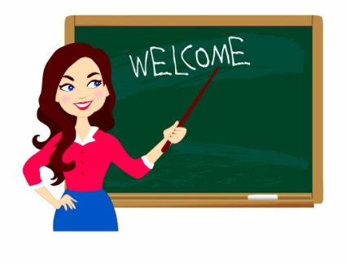
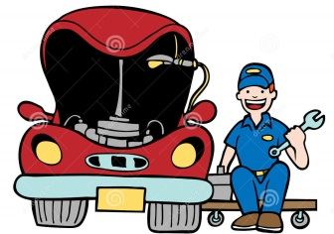

- What do you want to be? A song.
Kaj si želiš postati? Poslušaj in zapoj (če želiš). Klikni na spodnjo povezavo.

https://www.youtube.com/watch?v=MdvTlQzsaYI


