FINAL REVISION - NUMBERS

- Click on the link. Listen, read and say the words. Click on the pictures to hear the words.
Klikni na spodnjo povezavo. Poslušaj, beri in povej besede. Klikni na sličice, da boš slišal(a) besede.

- Števila 1-12
https://www.esolcourses.com/uk-english/beginners-course/unit-1/numbers-1-12/numbers-1-12-vocabulary.html
- Števila 13-24
https://www.esolcourses.com/uk-english/beginners-course/unit-2/numbers-13-to-24/numbers-13-24-vocabulary.html

- Click on the links and practise the numbers.
Klikni na spodnje povezave in vadi števila.

https://www.esolcourses.com/uk-english/beginners-course/unit-1/numbers-1-12/numbers-1-12-picture-quiz.html

https://www.esolcourses.com/uk-english/beginners-course/unit-2/numbers-13-to-24/numbers-13-24-picture-quiz.html

https://www.esolcourses.com/uk-english/beginners-course/unit-2/numbers-13-to-24/missing-letters-gap-fill.html

- Copy in your notebook.
Prepiši v zvezek.

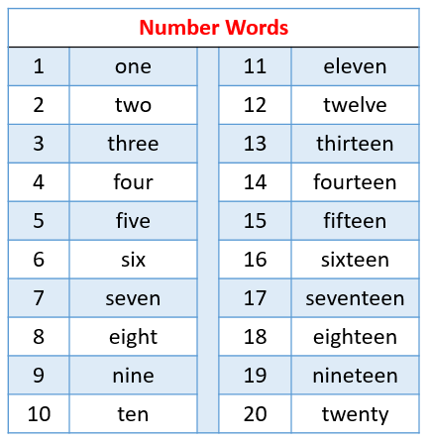

- Unscramble the words.
Razvozlaj besede.
1 | eon
2 | wot
3 | eehrt
4 | oruf
5 | iefv
6 | ixs
7 | enesv
8 | gtehi
9 | einn
10 | nte

- Complete the words.
Dopolni besede.
11 | _L_V_N |  | 16 | S_XT_ _N
12 | TW_LV_ |  | 17 | S_V_NT_ _N
13 | TH_RT_ _N |  | 18 | _ _GHT_ _N
14 | F_ _RT_ _N |  | 19 | N_N_T_ _N
15 | F_FT_ _N |  | 20 | TW_NTY

