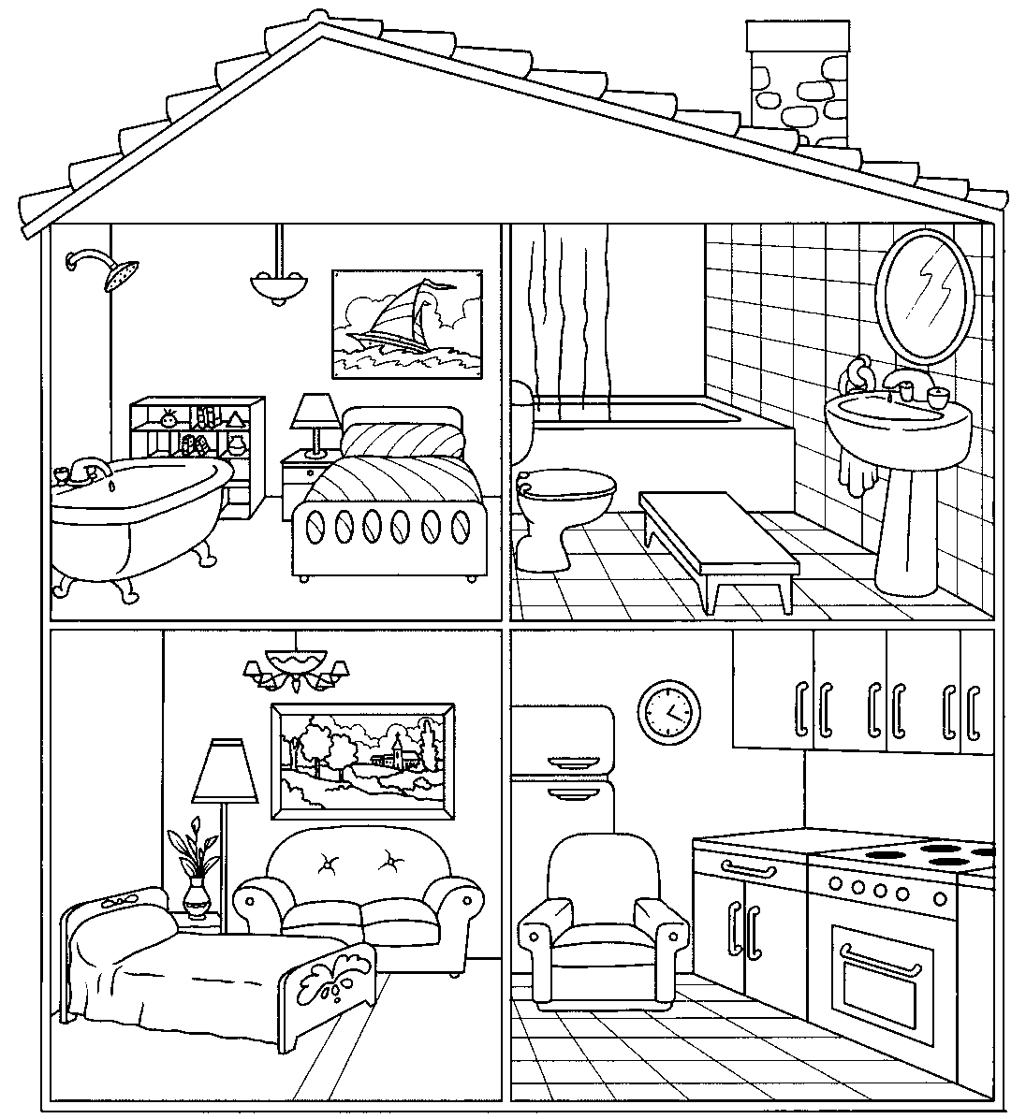
43
MATCH THE FURNITURE AND THE OBJECTS:
____This is a bath ______ This is a shower _______This is a mirror
____This is a bed ______ This is a stove _______This is a cabinet
____This is a fridge ______ This is a table _______This is a picture
____This is a lamp ______ This is a toilet _______This is a sink
____This is a curtain ______ This is a sofa
61
21
81
1019
71
143019
12411019
1351019
91
3
112019
51
1

