FINAL REVISION – BODY PARTS

- Click on the link. Watch, listen and repeat.
Klikni na spodnjo povezavo. Glej, poslušaj in ponovi besede.

https://www.youtube.com/watch?v=j6g_OPGdblU

- Click on the link. Sing along.
Klikni na spodnjo povezavo. Zapoj. Katera različica ti je bolj všeč?
https://www.youtube.com/watch?v=ZanHgPprl-0
https://www.youtube.com/watch?v=WX8HmogNyCY

- Time to play. Click on the link(s).
Čas za igro. Spodnje povezave ti bodo odprle različne igre, s katerimi lahko utrjuješ svoje znanje.
- Match the word and the picture.
https://learnenglishkids.britishcouncil.org/word-games/parts-the-body-1
https://learnenglishkids.britishcouncil.org/word-games/parts-the-body-2
- Memory game.
https://www.freddiesville.com/games/body-parts-memory-game/
- Word search puzzle.
https://www.freddiesville.com/games/body-parts-word-search-puzzle-online/

- Write the numbers.
Oštevilči.

1 shoulder 2 foot 3 head 4 finger 5 hand 6 toes 7 eye 8 ear 9 leg 10 hair 11 knee 12 elbow 13 mouth 14 arm 15 nose

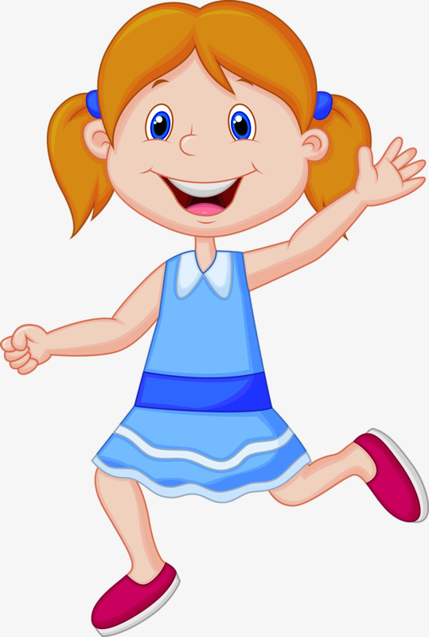

- I'm a spring chicken
Do you remeber? Listen and sing if you want.
Se še spomniš? Poslušaj in zapoj, če želiš.
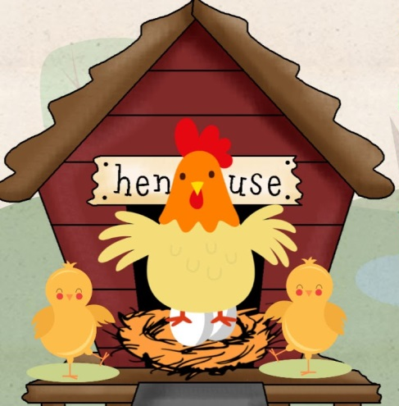

https://www.youtube.com/watch?v=IEey4LZLeGw

