FINAL REVISION – WEATHER,
DAYS OF THE WEEK

- WEATHER. Click on the link. Sing along.
Klikni na spodnjo povezavo. Poslušaj in zapoj pesem.

https://www.youtube.com/watch?v=sUkMzQ_UMrQ

- Time to play. Click on the link.
Čas za igro. Klikni na spodnjo povezavo.
https://learnenglishkids.britishcouncil.org/word-games/weather-1

- DAYS OF THE WEEK. Click on the link. Listen and sing the song.
Klikni na spodnjo povezavo. Poslušaj in zapoj pesem.
https://www.youtube.com/watch?v=mXMofxtDPUQ

- Time to play. Click on the links.
Čas za igro. Klikni na spodnji povezavi.
https://www.eslgamesplus.com/days-of-the-week-esl-vocabulary-game/
https://www.abcya.com/games/days_of_the_week

- WEATHER.

- What's the weather like today? (Kakšno vreme je danes? Napiši odgovor.)
It’s……………………………………………………………………

- Describe the weather. Zapiši, kakšno je vreme.
 | …………………………………………… |  | 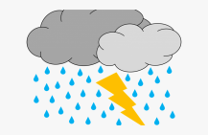  It's stormy.
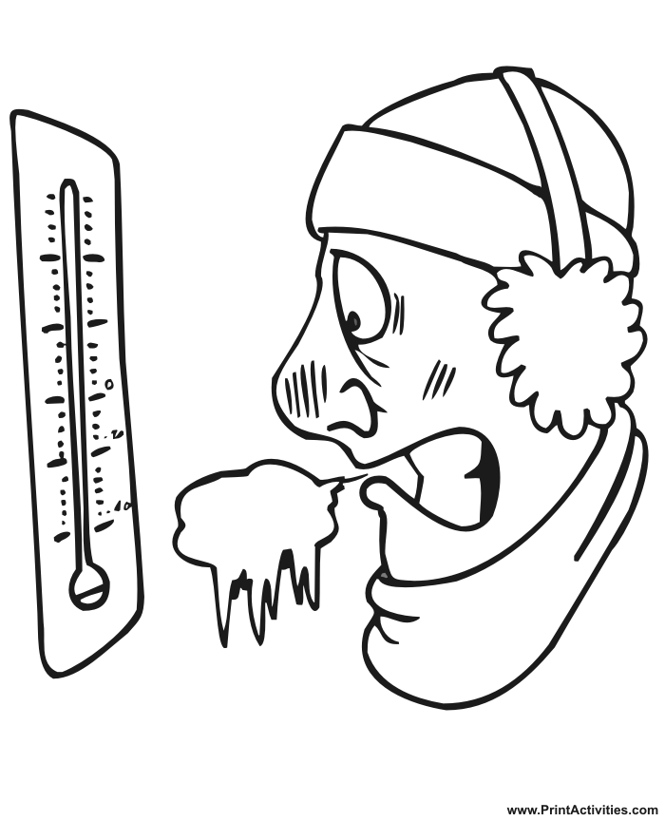 | …………………………………………… |  | It's hot.
 | …………………………………………… |  |   It's cloudy.
 | ……………………………………………… |  | 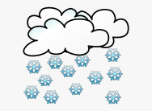  It's snowing.
 | ……………………………………………… |  | It's raining.
 | ……………………………………………… |  | It's sunny.
 | ……………………………………………… |  | It's cold.
 | ……………………………………………… |  | It's foggy.

- DAYS OF THE WEEK.
- Order the days. Zapiši dneve v pravilnem vrstnem redu.

Friday Tuesday Sunday Wednesday Saturday Monday Thursday

- Monday 2. 3. 4.

5. 6. 7.
b) Write the missing words. Dopiši manjkajoče črke.
_r_da_
We_ _esd_y
_ue_day
S_nd_ _
_ond_ _
Th_r_ _ay
S_t_rd_ y

