FINAL REVISION – TIME,
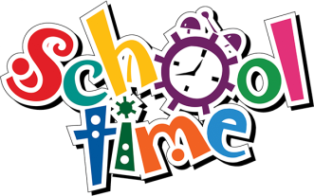
THIS IS ME

- TIME. Click on the link.
KOLIKO JE URA? Klikni na spodnjo povezavo in ponovi.

https://www.youtube.com/watch?v=EIxaxnageTo

- REPEAT. Find the explanation in your notebook and read it.
V zvezku poišči zapis – razlago z naslovom WHAT'S THE TIME. Natančno preberi.

- Time to play. Click on the link.
Čas za igro. Klikni na spodnjo povezavo
- in izberi zaporedno številko 1 : HOURS, MULTIPLE CHOICE QUESTIONS
- na isti povezavi nato izberi zaporedno številko 10: FIVE MINUTES TO, MULTIPLE CHOICE QUESTIONS
- naslednja zaporedna številka je 11: FIVE MINUTES PAST, MULTIPLE CHOICE QUESTIONS
- če želiš, klikni še na zaporedno številko 12: FIVE TO AND FIVE PAST, MULTIPLE CHOICE QUESTIONS

https://www.helpfulgames.com/subjects/mathematics/tell-time.html

- What's the time? Write.
Koliko je ura? Zapiši v celi povedi.

0 | 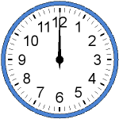 | It' twelve o'clock.
1 | 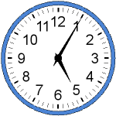
2 | 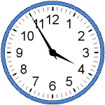
3 | 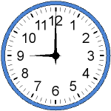
4 | 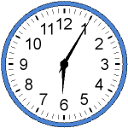
5 | 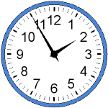
6 | 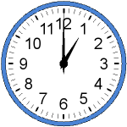

- THIS IS ME. Complete and read aloud.
TO SEM JAZ. Dopolni in preberi na glas.


My name is _______________.
I am ______________ years old.
My birthday is in ________________.
My hobby is __________________.
I like ________________.

I don't like______________.

Rešitve: 1. It's five past five. 2. It's five to four. 3. It's nine o'clock. 4. It's five past six. 5. It's five to two. 6. It's one o'clock.
Pomagaj si z zapisom v zvezku. Ne pozabi: meseci se pišejo z veliko začetnico.

