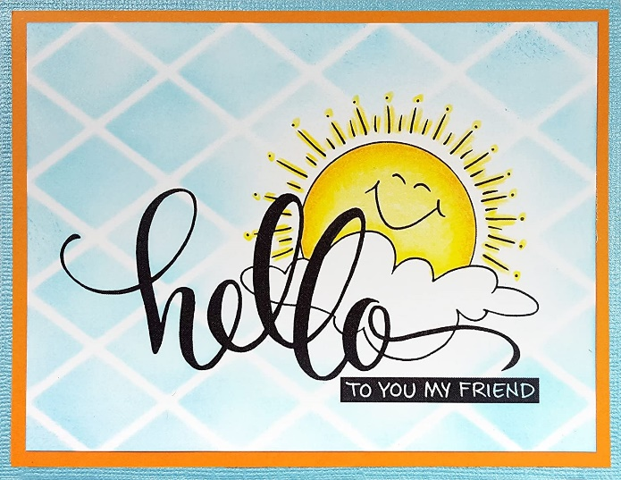

HELLO ELEPHANTS, MOLES, BEES AND TURTLES!!
POZDRAVLJENI SLONČKI, KRTKI, ČEBELICE IN ŽELVICE!

NAVODILA
- PONOVNO POSLUŠAJ PESEM O MORSKIH PSIH NA TEJ POVEZAVI.
- OGLEJ SI POSNETEK Z NAVODILI NA TEJ POVEZAVI.
- PRESLIKAJ ZAPIS V ZVEZEK (glej naslednjo stran) IN DORIŠI ČLANE POLJUBNE DRUŽINE.

GOODBYE ELEPHANTS, MOLES, BEES AND TURTLES!

HAVE A WONDERFUL DAY!
SINCERELY YOURS
TEACHER KAJA

FAMILY MEMBERS
MOTHER – MOMMY FATHER – DADDY
risba
GRANDMOTHER – GRANDMA GRANDFATHER – GRANDPA
risba
risba
risba
BROTHER SISTER
risba
risba

