A Healthy Lifestyle
Listen to and read the following:

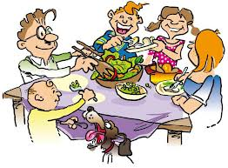
The Thomson family has been trying to eat healthy meals for a very long time, but found it difficult to keep it up. Mr and Mrs Thomson work long hours at the hospital, and feel exhausted when they arrive home. They also have three young children who needed a lot of care. David is eight years old, their daughter Ann is six and the baby is one. It is difficult for the family to cook healthy meals every day. For months, Mrs Thomson has been ordering food during the week, which is delivered after they arrive from work. This is a bad routine, and the Thomson’s know this fact very well and have started to worry that their children will get so used to eating fast food; it will be difficult for them to change this habit. For the past two weeks, they have been eating healthy homemade meals and feel very excited about it.

Name: | Date:
Answer the following questions.

1. Does the Thomson family eat healthy meals?
____________________________________________________________
2. How many children do they have?
____________________________________________________________
3. Who orders food every day?
____________________________________________________________
4. Are they worried about their bad eating habits?
____________________________________________________________
5. Do you think they will continue to eat homemade food? Why? ____________________________________________________________

