SESTAVNI DELI 4-TAKTNEGA BENCINSKEGA MOTORJA

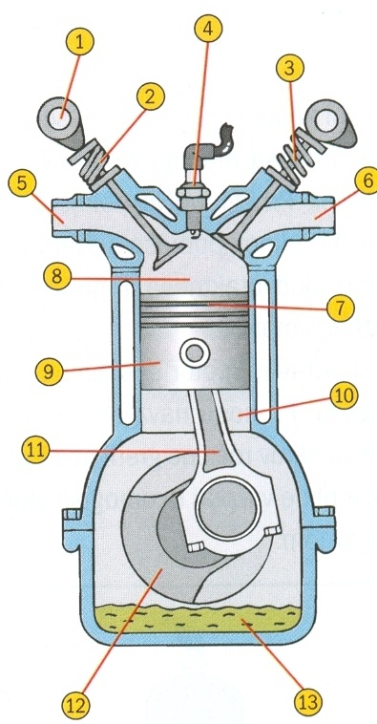
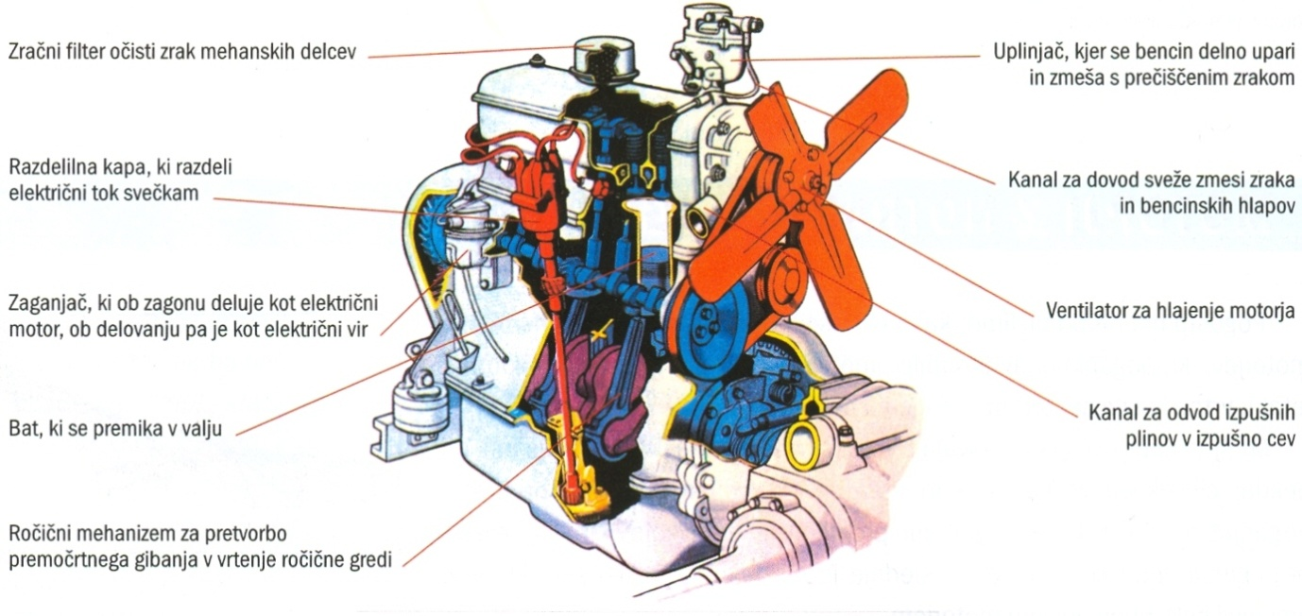

Zapiši sestavne dele 4-taktnega bencinskega motorja!

1 _________________________________
2 _________________________________
3 _________________________________
4 _________________________________
5 _________________________________
6 _________________________________
7 _________________________________
8 _________________________________
9 _________________________________
10 _________________________________
11 _________________________________
12 _________________________________
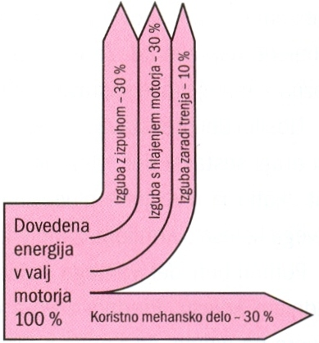
13 _________________________________

Zakaj je izkoristek 4-taktnega bencinskega
motorja le okrog 30 %?
___________________________________
___________________________________
___________________________________
___________________________________

