FINAL REVISION – LET'S SING

- SONG. Click on the link, listen and sing.
Pesem INCY WINCY SPIDER. Klikni na povezavo, poslušaj in poskusi peti.
https://www.youtube.com/watch?v=aFNPZ5SCfWo

- Put the story in the right order.
Oštevilči sličice v pravilnem vrstnem redu.

2
1
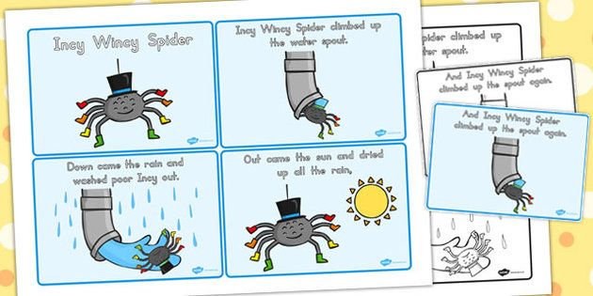

- Write the words under the right picture.
Besede zapiši pod pravilno sličico.
SPOUT SUN RAIN SPIDER
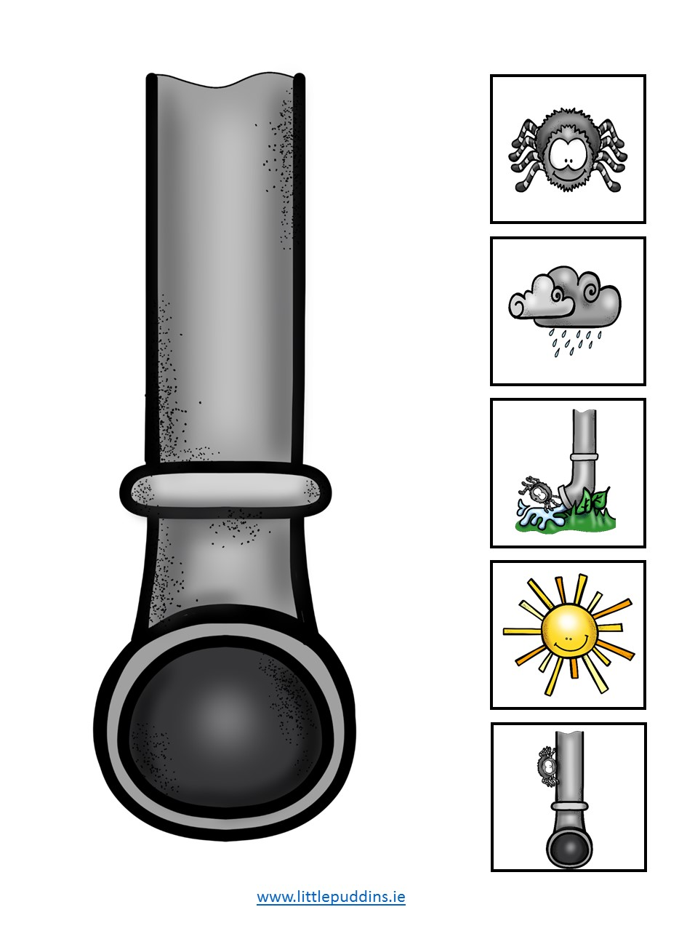

___________ ______________ ___________ ________

- Put the song in the right order.
Oštevilči sličice v pravilnem vrstnem redu.
 | Incy Wincy spider climbed up the spout again.
 | Out came the sun and dried up all the rain,
1 | Incy Wincy spider climbing up the spout,
 | Down came the rain and washed the spider out,

- SONG. Click on the link, listen and sing.
Pesem MY BONNIE LIES OVER THE OCEAN. Klikni na povezavo, poslušaj in zapoj.
https://www.youtube.com/watch?v=8jGurbBx6hk
- Gap fill.
Dopolni pesem z manjkajočimi besedami.

WINDS BACK SEA BONNIE OCEAN BRING

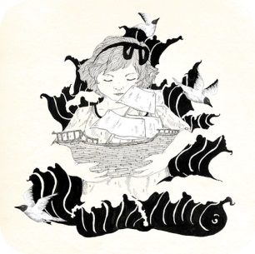
My Bonnie lies over the ¹________
My Bonnie lies over the sea
My ²__________ lies over the ocean
Oh, bring back my Bonnie to me...
Bring back, bring back
³________ back my Bonnie to me, to me
Bring back, bring ⁴_______
Bring back my Bonnie to me
The ⁵_________ will blow over the ocean
The winds will blow over the ⁶_______
The winds will blow over the ocean
to bring back my Bonnie to me

- SONG. Click on the link, listen and sing.
Pesem WINNIE'S SONG. Klikni na povezavo, poslušaj in zapoj.

https://www.youtube.com/watch?v=kuycjD-xXOQ

- Write the numbers.
Oštevilči krepko označene vrstice pesmi na slikah.

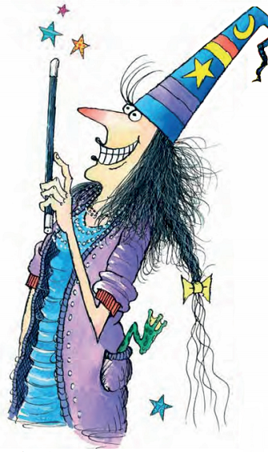
A big tall hat¹,

Ten long toes,

A black magic wand²,

A long red nose³.
She's Winnie⁴,
Winnie the witch.

A long black tail⁵,
Big green eyes⁶,
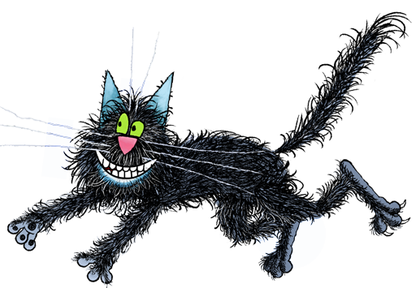
He goes with Winnie
When she flies.

He's Wilbur⁷,
Wilbur the cat.

Prva vrstica je malo drugačna od tiste pesmi, ki smo se je učili lani: Incy Wincy Spider climbed up the water spout in Incy Wincy Spider climbing up the spout Žal je te posnetek pesmi na zgoščenki spravljen v šoli.
Rešitve: 1,2,5,4,3.
Rešitve: 4,3,1,2.
Rešitev: 1 ocean 2 Bonnie 3 bring 4 back 5 winds 6 sea

