REVISION – PRONOUNS, HAVE GOT

- Copy this page into your notebook.
Vse na tej strani prepiši v zvezek.
PERSONAL PRONOUNS | OSEBNI ZAIMKI
I | jaz
you | ti
he | on
she | ona
it | ono
we | midva, mi
you | vidva, vi
they | onadva, oni

HAVE GOT -imeti

VPRAŠALNA OBLIKA
NIKALNA OBLIKA
TRDILNA OBLIKA

dolga oblika
skrajšana oblika

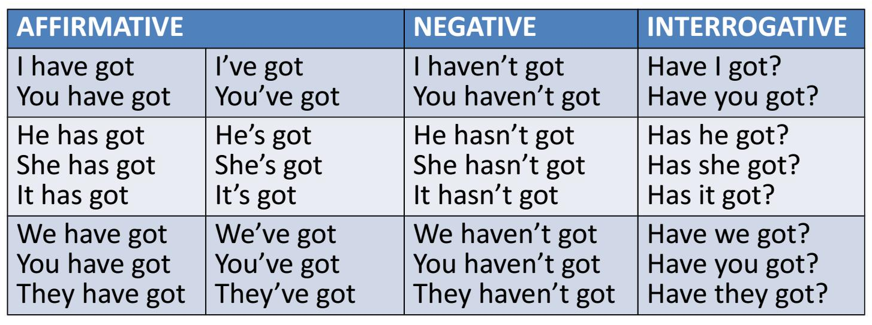

Examples: | He's got a new car. | On ima nov avto.
Examples: | You haven't got a new car. | Ti nimaš novega avta.
Examples: | Have they got a new car? | Imajo oni nov avto?
- Complete the sentences with have got or has got. If there is a (-) use haven't got or hasn't got.
Dopolni povedi s have got ali has got. Če je na koncu povedi (-), uporabi haven't got ali hasn't got
- I _______________ a nice room.
- She _____________ a cat.
- Jack ______________ a pet.
- The sisters ______________ great teachers.
- He ______________ an old bike.
- They ______________ a goldfish.
- Emma ______________ lots of friends.
- We _______________ a problem.
- Joe and Philip _______________ a sister.
- My uncle _____________ two cars.
- I can't open the door. I _______________ a key. (-)
- Ben __________________a lot of books. (-)
- ____________ my friend __________ an orange basketball?
- Hurry up! We ________________ much time. (-)
- _____________ my parents _____________ a big bedroom?
- What ____________ you __________ in your schoolbag?
- My uncle __________________ a son or a daughter. (-)
- She wants new jeans, but she __________________ the money. (-)
- ___________ my bother __________ long black hair?
- I ______________ an elephant. (-)

- Click on the link and practise.
Klikni na spodnjo povezavo:

  - Preberi razlago z naslovom Have got še enkrat.
  - Pod razlago najdeš dve igri (Game). Klikni na besedo (Game) in preizkusi svoje znanje.

https://learnenglishkids.britishcouncil.org/grammar-practice/have-got

Rešitve: 1have got, 2has got, 3has got, 4have got, 5has got, 6have got, 7has got, 8have got, 9have got, 10has got, 11haven't got, 12hasn't got, 13Has my friend got…, 14haven't got, 15Have my parents got…, 16have you got…, 17hasn't got, 18hasn't got, 19Has my brother got…, 20 haven't got

