FINAL REVISION – The Snail and the Whale
- STORY. Click on the link and listen to the story.
THE SNAIL AND THE WHALE. Klikni na povezavo, poslušaj in beri zgodbo.
https://www.youtube.com/watch?v=3ZAtKDaFU6c

- Write the numbers in the right box.
Oštevilči sličice.

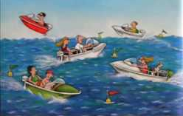
- The snail had an itchy foot.
- This is a whale with its tail.

- These are towering icebergs.
- These are fiery mountains.
- These are the waves that arched and splashed.
- These are the speedboats, running a race.
- These are the children running in from their play.

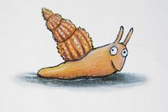
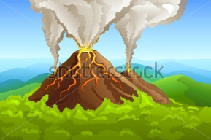

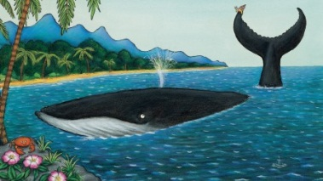



- Find the words from the box in the story.
V zgodbi poišči besede iz okvirčka. Poskusi si jih zapomniti.
POLŽ KIT STOPALO SVET REP LEDENIKI GORE VALOVI VOTLINE GLISERJI OTROCI GASILCI MORJE

This is a tale of a tiny snail
and a great big humpback whale.

The snail has an itchy foot
and wants to travel around the world.
Then comes a whale with its tail.
They visit towering icebergs and far-off lands,
fiery mountains and golden sands.
They see the waves that arch and splash.
They go to the caves beneath the waves.

The speedboats are running a race,
zigging and zooming allover the place.
The whale lies beached in a bay.
The children run in from their play.
The snail writes »Save the whale«.
The children, the firemen dig and spray.
The villagers shout, »Hooray!«

On the tail crawl snail after snail after snail
and sing to the sea as they all set sail.

Rešitve: zgoraj desno 6, od leve proti desni: 3, 4, 1, 5, 7, 2
Rešitev: Besede v okvirčku so zapisane v istem vrstnem redu, kot se pojavijo v zgodbi.

