FINAL REVISION – Room on the Broom

- STORY. Click on the link.
ROOM ON THE BROOM. Klikni na povezavo.

https://www.youtube.com/watch?v=aOTUq1ceTuc

- SONG. Click on the link.
ROOM ON THE BROOM. Klikni na povezavo. Poslušaj in beri.

https://www.youtube.com/watch?v=XsfhYNH6O-8
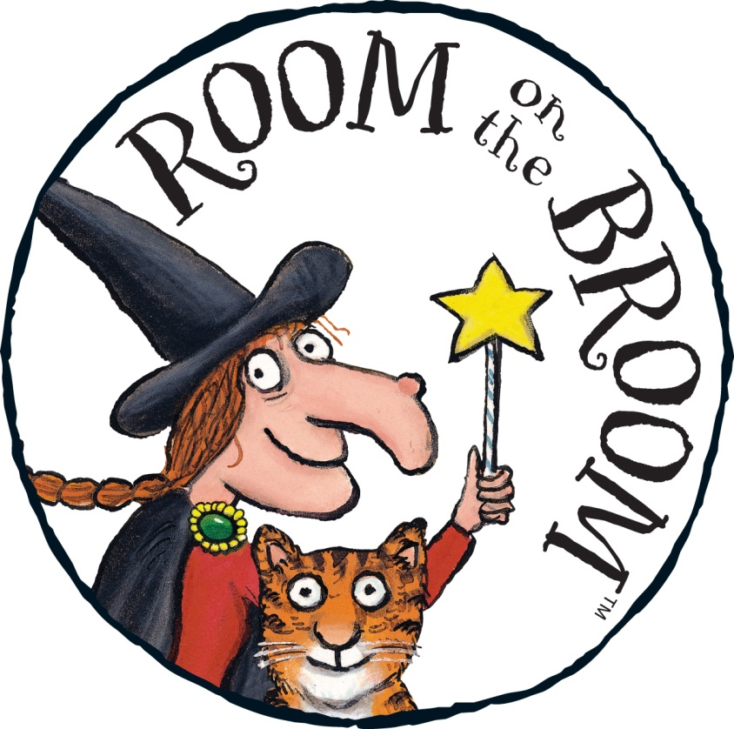

- PICTURE STORY. Read the story.
Preberi zgodbo. Sličice poimenuj s pravilnimi besedami v angleščini. Pomagaj si z besedami v okvirčku.
witch cat broom hat dog bow bird wand frog dragon cone bone twig lily broom seats nest shower

A 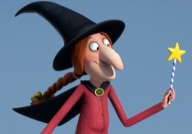 and a 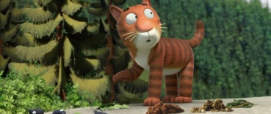 were on the 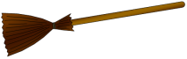.
The witch lost her 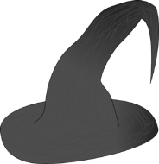. A 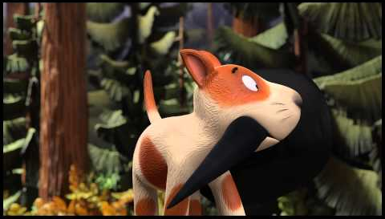 found the hat. The witch, the cat and the dog were on the broom. The witch lost her . A green 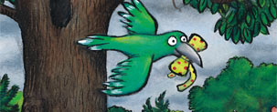 found the bow. The witch, the cat, the dog and the bird were on the broom. The witch lost her . A green 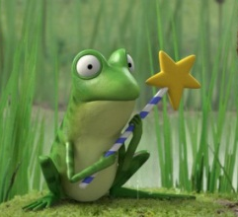 found the wand. The witch, the cat, the dog, the bird and the frog were on the broom. The broom broke into two pieces.
A hungry 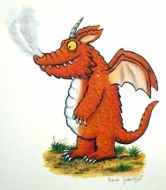 wanted to eat the witch. A monster with four heads scared away the dragon.
The cat put a 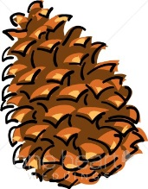, the dog put a , the bird put a 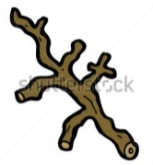 and the frog put a 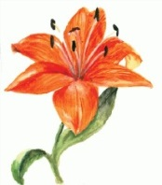 in the cauldron, the witch said the spell and out came a truly magnificent 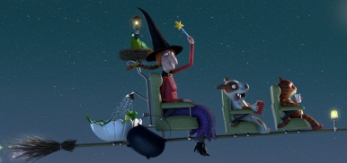!
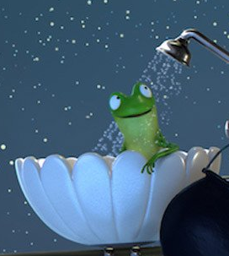
The witch, the cat and the dog had 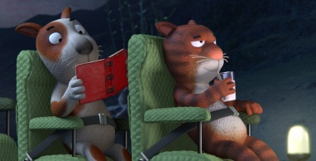, the bird had a 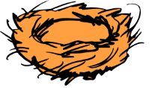 and the frog had a on their new broom.

Rešitve: besede v okvirčku so zapisane v vrstnem redu kot jih je potrebno uporabiti v zgodbi.

