Our monthly weather
MAY 2020
What is the weather like?
DATE: |  |  |  |  |  |  | 
1st May |  |  |  | x
2nd May |  | x |  | x
3rd May | x
4th May
5th May
6th May
7th May
8th May
9th May
10th May
11th May
12th May
13th May
14th May
15th May
16th May
17th May
18th May
19th May
20th May
21st May
22nd May
23rd May
24th May
25th May
26th May
27th May
28th May
29th May
30th May
31st May
MY WEATHER REPORT:
This month was mostly ________________.
There were ____ sunny days.
There were ____ partly cloudy days.
There were ____ cloudy days.
There were ____ rainy days.
There were ____ stormy days.
There were ____ windy days. There were ____ snowy days.

Our monthly weather
MAY 2020
What are the temperatures like?
DATE: | cold | cool | warm | hot | very hot
1st May |  |  | x
2nd May |  | x
3rd May |  |  | x
4th May
5th May
6th May
7th May
8th May
9th May
10th May
11th May
12th May
13th May
14th May
15th May
16th May
17th May
18th May
19th May
20th May
21st May
22nd May
23rd May
24th May
25th May
26th May
27th May
28th May
29th May
30th May
31st May
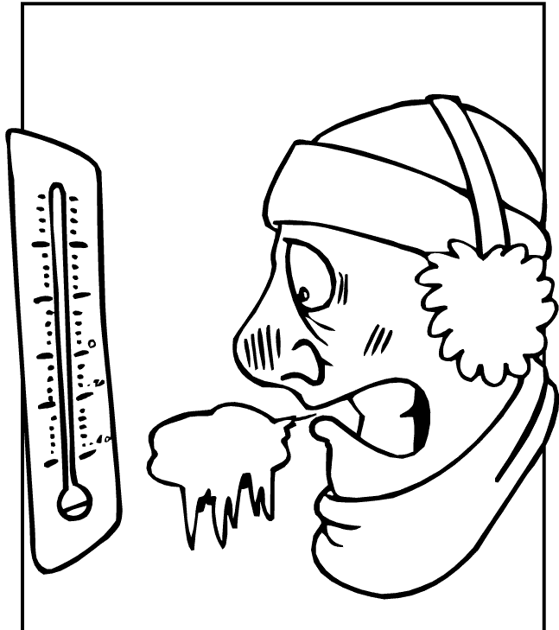

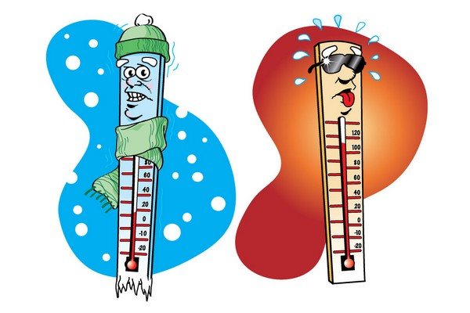



There were ____ cold days.
There were ____ cool days.
There were ____ warm days.
There were ____ hot days.
There were ____ very hot days.

MY WEATHER REPORT:
This month was mostly ________________.

