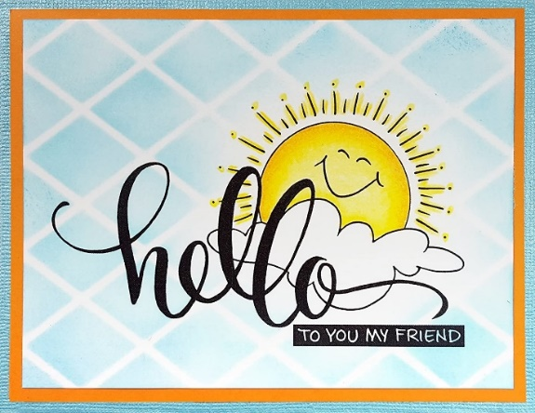

HELLO ELEPHANTS, MOLES, BEES AND TURTLES!!
POZDRAVLJENI SLONČKI, KRTKI, ČEBELICE IN ŽELVICE!

NAVODILA

- OGLEJ SI POSNETEK Z NAVODILI ZA NOVO IGRO NA TEJ POVEZAVI.
- POVADI IGRO S SVOJO PLIŠASTO IGRAČO ALI Z DRUŽINO. POMAGAŠ SI LAHKO Z BESEDILOM.


CRISS CROSS

CRISS, CROSS, APPLESAUCE.
SPIDERS CRAWLING

UP YOUR BACK.
COOL BREEZE,
TIGHT SQUEEZE.
NOW YOU'VE GOT
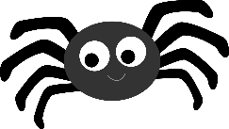
THE SHIVERS!

GOODBYE ELEPHANTS, MOLES, BEES AND TURTLES!
HAVE A WONDERFUL DAY!
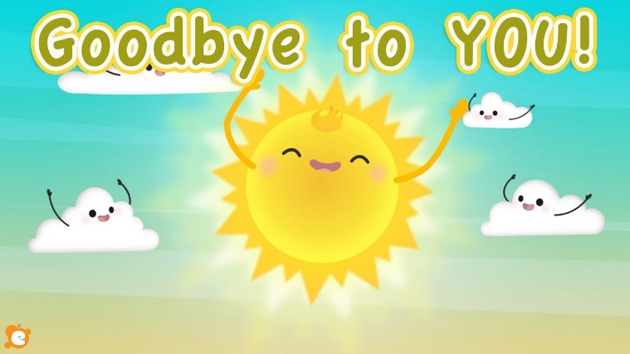
SINCERELY YOURS
TEACHER KAJA

