FINAL REVISION – Winnie Flies Again
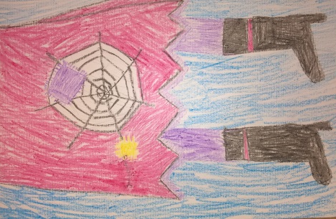
- STORY. Click on the link.
WINNIE FLIES AGAIN. Klikni na povezavo. Poslušaj zgodbo.

https://www.youtube.com/watch?v=spnrxJGrFtI

- SONG. Click on the link and sing.
WINNIE FLIES AGAIN. Klikni na povezavo in zapoj.

https://www.youtube.com/watch?v=kuycjD-xXOQ

- Read the words.
Preberi besede.

WAND BROOMSTICK HANG GLIDER HOLE BUILDING GLASSES = SPECTACLES POND TREE CUP OF TEA BICYCLE BALLOON SKATEBOARD AIRPLANE HAT

- Point to the picture and say the word.
Poimenuj spodnje sličice. Zgornje besede so ti lahko v pomoč.
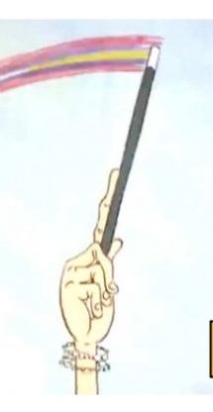
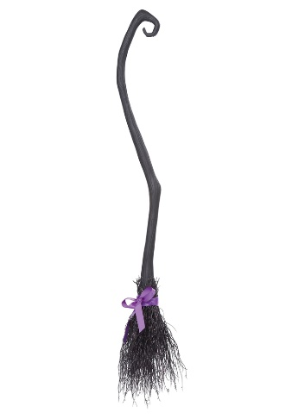
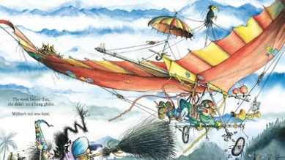

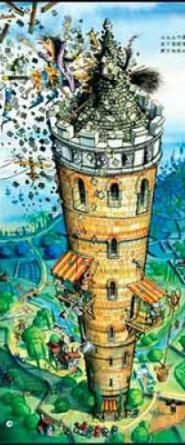

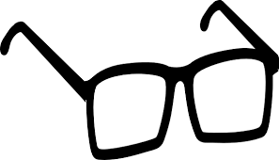
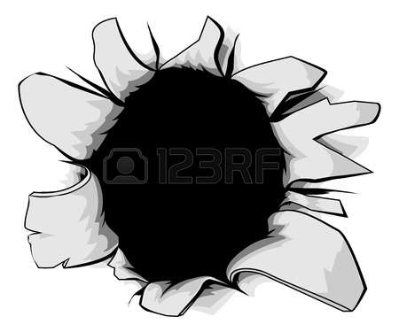

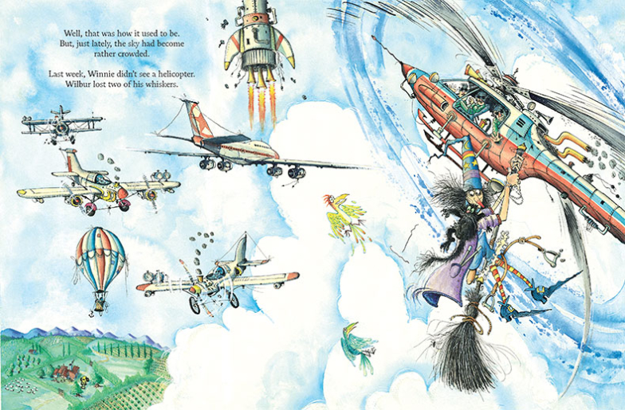


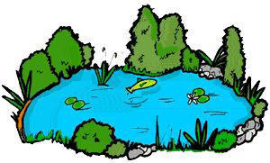

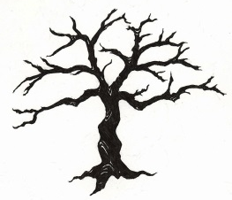
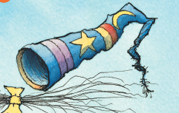
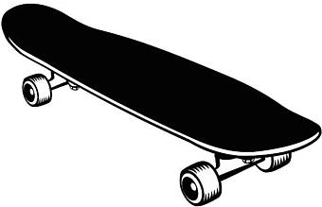

- Make sentences.
Iz danih besed tvori povedi.

- very busy / The sky / was
___________________________________________________
- a helicopter / Winnie / crashed into
___________________________________________________
- Winnie / ABRACADABRA / and said / her black magic wand / took
___________________________________________________
___________________________________________________
- easy / Riding a bicycle / was not
___________________________________________________
- the tree / didn't see / Winnie
___________________________________________________
- and some milk / wanted / Winnie / a cup of tea
___________________________________________________

Rešitve: a) The sky was very busy. b) Winnie crashed into a helicopter. c) Winnie took her black magic wand and said ABRACADABRA! d) Riding a bicycle was not easy. e) Winnie didn't see the tree. f) Winnie wanted a cup of tea and some milk.

