IZDELAVA IN OKRASITEV CVETLIČNEGA LONČKA
CILJ: Učenci iz odpadnega materiala izdelajo svoj cvetlični lonček in ga poljubno okrasijo.

- i d e j e -
Cvetlični lonček iz plastenke
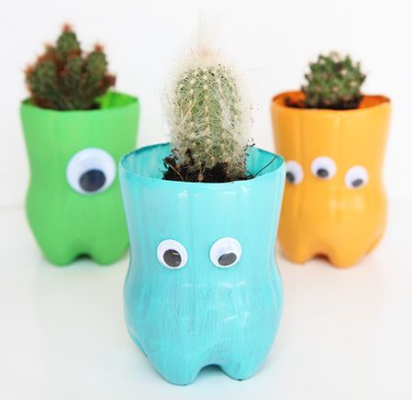  Vir: https://www.pinterest.com/pin/364580532323914199/ (pridobljeno 15. 4. 2020) | 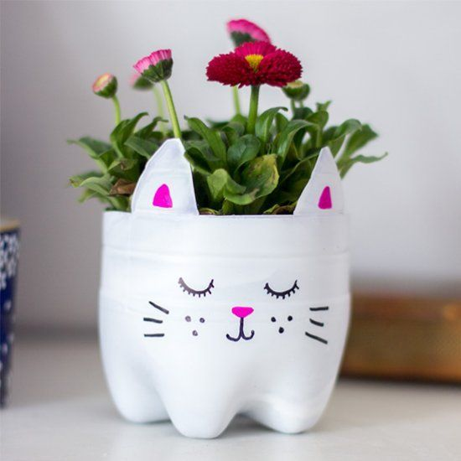  Vir: https://www.pinterest.com/pin/542894930083173177/ (pridobljeno 15. 4. 2020)
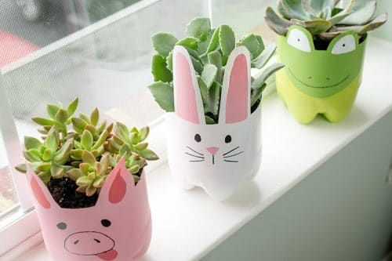  Vir: https://www.pinterest.com/pin/ASbB4LQx5coqs51bPYt1ncqkdJPS5nNLWTIjViaVv3sME8mo9l45jsc/ (pridobljeno 15. 4. 2020) | 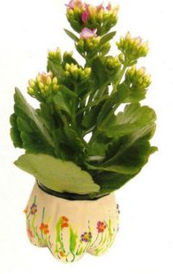  Vir: https://www.pinterest.com/pin/698902435908372480/ (pridobljeno 15. 4. 2020)
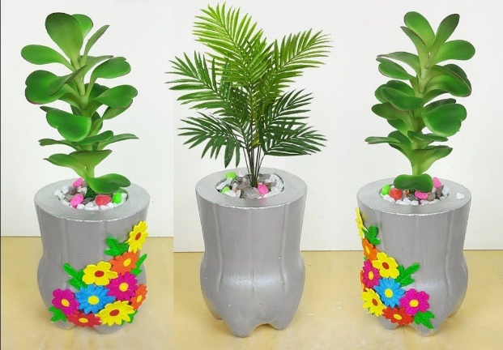  Vir: https://www.pinterest.com/pin/534169205801464361/ (pridobljeno 15. 4. 2020) | 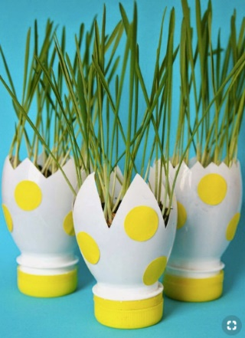  Vir: https://mydesiredhome.com/25-creative-diy-ideas-with-beautiful-pots-to-welcome-spring/ (pridobljeno 15. 4. 2020)
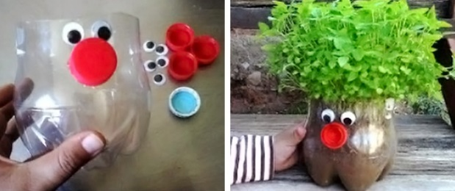  Vir: https://brightside.me/inspiration-tips-and-tricks/10-creative-ways-to-make-beautiful-flowerpots-from-ordinary-plastic-bottles-200405/ (pridobljeno 15. 4. 2020) | 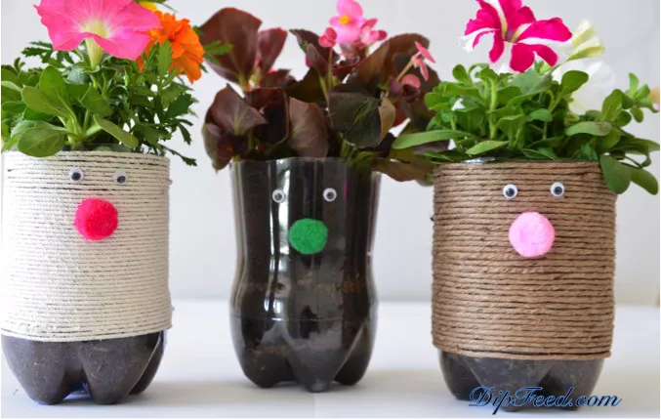  Vir: https://www.thespruce.com/ways-to-reuse-plastic-bottles-4584358 (pridobljeno 15. 4. 2020)

Cvetlični lonček iz pločevinke
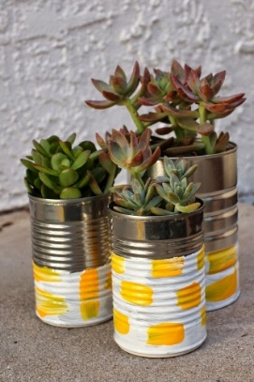  Vir: https://www.pinterest.com/pin/118782508909080863/ (pridobljeno 15. 4. 2020) | 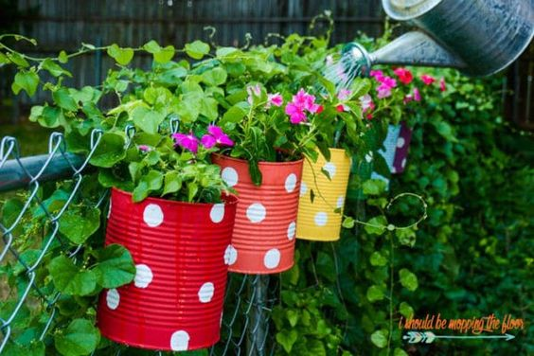  Vir: https://www.pinterest.com/pin/693695148842833955/ (pridobljeno 15. 4. 2020)
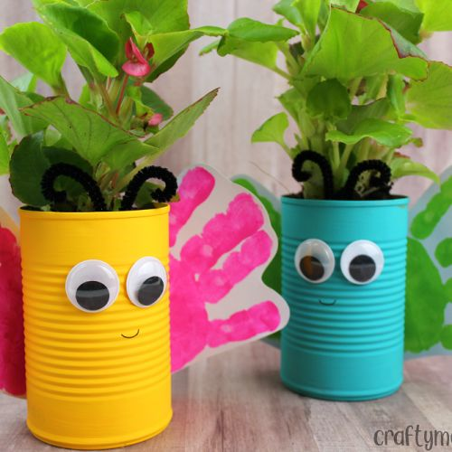  Vir: https://www.pinterest.com/pin/320951910938358086/ (pridobljeno 15. 4. 2020) | 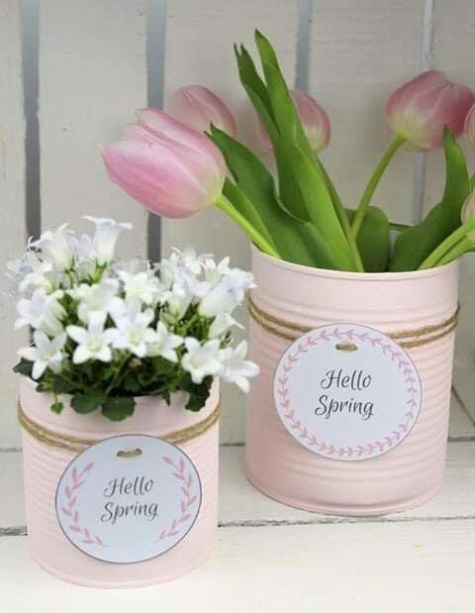  Vir: https://www.pinterest.com/pin/512284526367494451/ (pridobljeno 15. 4. 2020)
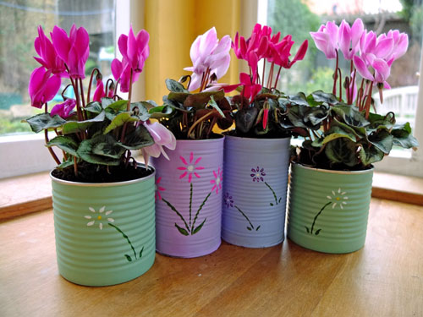
Vir: http://thinlyspread.co.uk/hanmade-christmas-painted-flower-pots/ (pridobljeno 15. 4. 2020)
Cvetlični lonček iz že obstoječega lončka
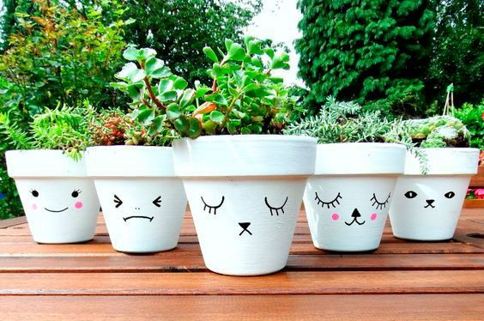  Vir: https://www.pinterest.com/pin/512003051388229822/ (pridobljeno 15. 4. 2020) | 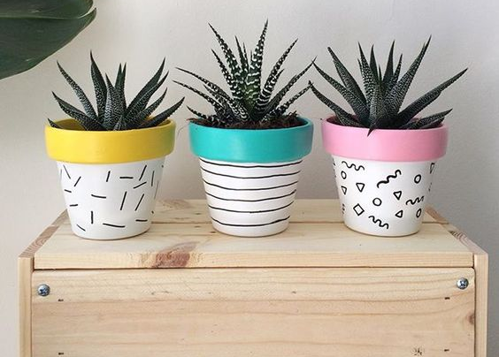  Vir: https://www.pinterest.com/pin/806918458218041063/ (pridobljeno 15. 4. 2020)
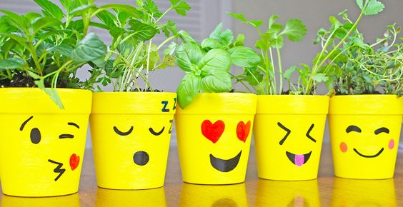  Vir: https://www.pinterest.com/pin/221872719124253291/ (pridobljeno 15. 4. 2020) | 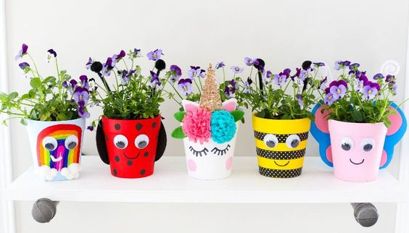  Vir: https://www.pinterest.com/pin/18014467248405005/ (pridobljeno 15. 4. 2020)
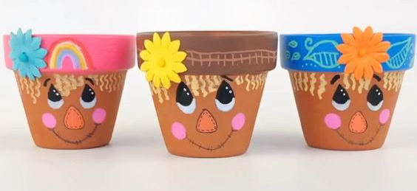  Vir: https://www.pinterest.com/pin/566116615662288493/ (pridobljeno 15. 4. 2020) | 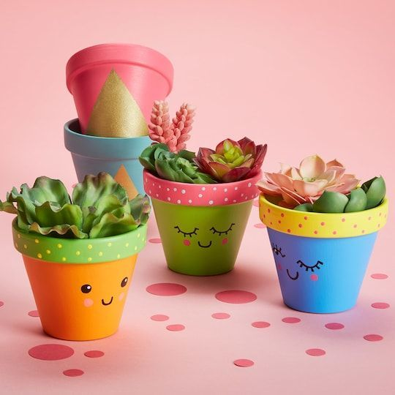  Vir: https://www.pinterest.com/pin/556335360222559027/ (pridobljeno 15. 4. 2020)

Cvetlični lonček prekrit (prelepljen) s palčkami/vrvico/ščipalkami/servieto
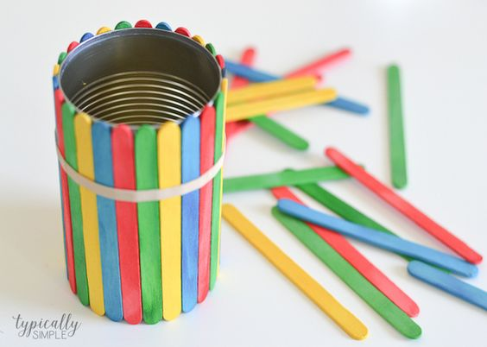  Vir: https://www.pinterest.com/pin/16114511148106944/ (pridobljeno 15. 4. 2020) | 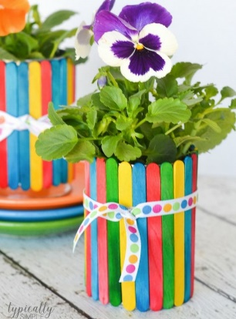  Vir: https://www.pinterest.com/pin/290622982204504196/ (pridobljeno 15. 4. 2020)
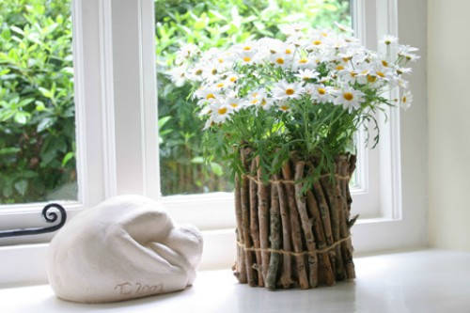  Vir: https://www.onecrazyhouse.com/diy-flower-pots/ (pridobljeno 15. 4. 2020) | 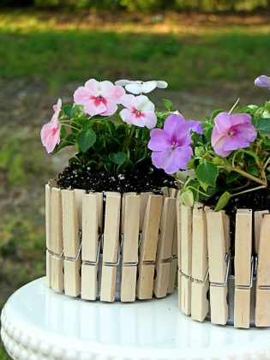  Vir: https://www.onecrazyhouse.com/diy-flower-pots/ (pridobljeno 15. 4. 2020)
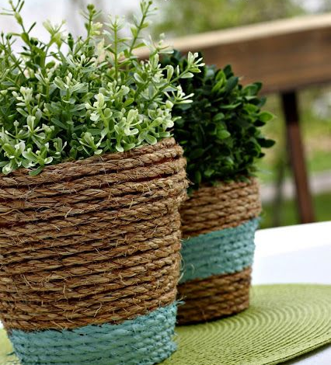  Vir: https://rainonatinroof.com/10-creative-planter-ideas/ (pridobljeno 15. 4. 2020) | 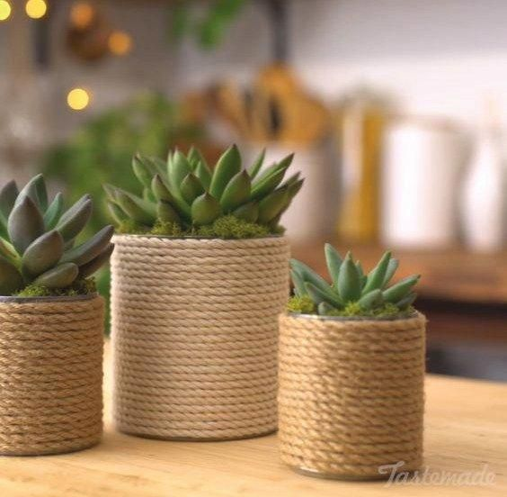  Vir: https://www.pinterest.com/pin/537969117990847240/ (pridobljeno 15. 4. 2020)
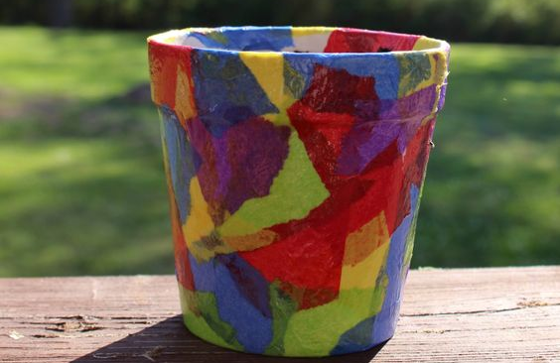  Vir: https://fromabcstoacts.com/tissue-paper-flower-pot/ (pridobljeno 15. 4. 2020) | 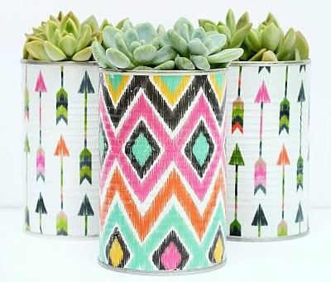  Vir: https://www.pinterest.com/pin/56787645278885235/ (pridobljeno 15. 4. 2020)
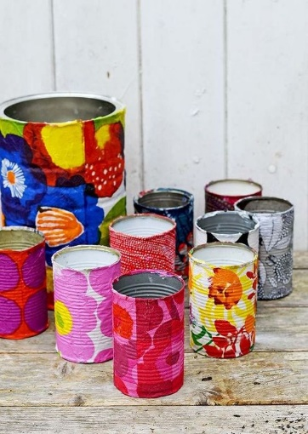
Vir: https://www.pinterest.com/pin/140526450859095058/ (pridobljeno 15. 4. 2020)

Cvetlični lonček iz jogurtovega lončka (in vrvice)
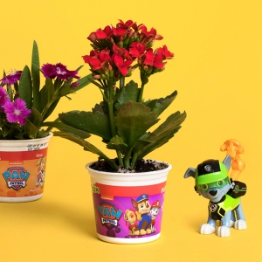  Vir: https://www.google.com/imgres?imgurl=http%3A%2F%2Fs3.amazonaws.com%2Fnickelodeonparents.com-production%2Fwp-content%2Fuploads%2F2017%2F03%2Fpaw-missionp-yf-1x1-300x300.jpg&imgrefurl=http%3A%2F%2Fwww.nickelodeonparents.com%2Fpaw-patrol-yogurt-cup-flower-pot%2F&tbnid=qHT-saImqStcyM&vet=12ahUKEwjxzoCp9OnoAhVWNewKHd-3C0QQMygJegUIARD2AQ..i&docid=UK2SoPhIzMz3iM&w=300&h=300&q=yoghurt%20cup%20diy%20flower%20pot%20&ved=2ahUKEwjxzoCp9OnoAhVWNewKHd-3C0QQMygJegUIARD2AQ (pridobljeno 15. 4. 2020) | 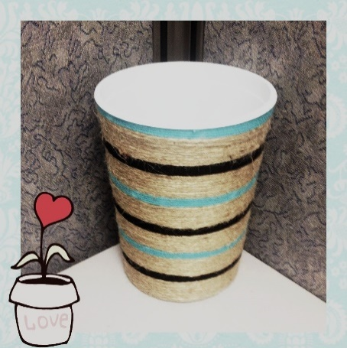  Vir: https://i.pinimg.com/originals/cb/d1/ce/cbd1ceef97f2c28e9e234c0dbd1f54e8.jpg (pridobljeno 15. 4. 2020)

Cvetlični lonček iz plastenke in zgoščenke
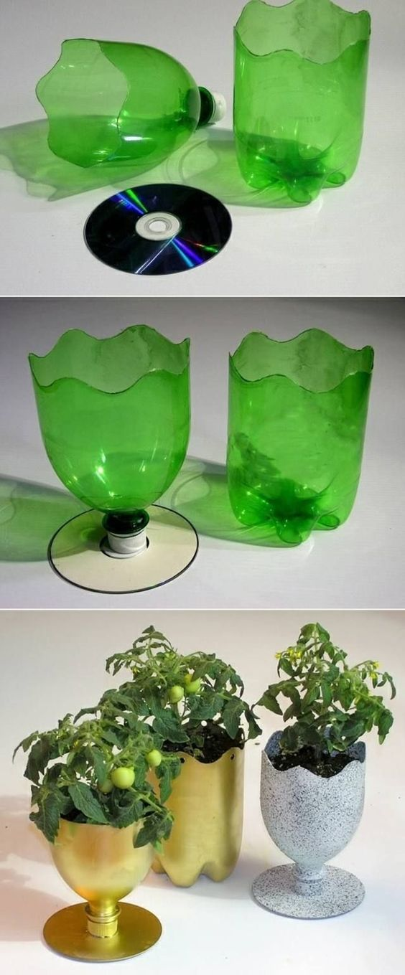
Vir: https://www.pinterest.com/pin/619385754989467978/ (pridobljeno 15. 4. 2020)

