

ENGLISH TEST
WEDNESDAY, 27. 05. 2020
LIVEWORKSHEETS

Drage učenke in učenci,
danes je pred nami zadnje poglavje ponavljanja & preverjanja znanja. V sredo (20. 05.) in v ponedeljek (25. 05.) bo še čas za utrjevanje, potem pa bomo pridobljeno znanje preverili in ocenili (sreda, 27. 05. 2020). Test bo v obliki interaktivnih učnih listov (LIVEWORKSHEETS), kot smo delali do sedaj. Podrobna navodila za samo pisanje testa bodo še sledila.

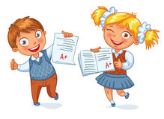

REVISION – THE SMARTEST GIANT IN TOWN

- Click on the link below. Listen and read the story.
Klikni na spodnjo povezavo. Poslušaj in beri zgodbo.

https://www.youtube.com/watch?v=iGxl-OV9190

- Repeat the song.
Ponovi pesem THE SMARTEST GIANT IN TOWN. Zapisano imaš v zvezku.

- Click on the link below. Try to sing along.
Klikni na spodnjo povezavo. Poskušaj zapeti pesem.

https://www.youtube.com/watch?v=tvsjjZ35sr0
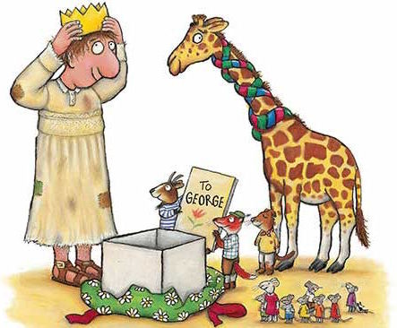

- Vocabulary. Translate.
Preveri znanje besedišča. Prevedi.

 | ENGLISH | SLOVENE
1 | a belt
2 | sandals
3 | a tie
4 | a gown
5 | socks
6 | trousers
7 | a shirt
8 | shoes
9 | a goat
10 | a dog
11 | a mouse
12 | a giraffe
13 | a fox
14 | a scarf
15 | a sail
16 | a house
17 | a bog
18 | a boat
19 | a bed
20 | a crown

- Put the words in the right order and write the sentences on the lines.
Iz danih besed tvori povedi.

a) wore / a pair of old brown sandals / George / and an old gown
________________________________________________________
b) some smart clothes / George / bought / One day
________________________________________________________
c) for a cold giraffe / His stripy tie / a wonderful scarf / was
________________________________________________________
d) needed / A goat / a new sail
____________________________________________________________
e) a house / One of his shoes / was / for a little white mouse
____________________________________________________________
f) was / for a fox / One of his socks / a bed
____________________________________________________________
g) a dog / His belt / helped
____________________________________________________________
h) brought / The animals / George / a paper crown and a card
____________________________________________________________

Rešitve: 1 pas 2 sandali 3 kravata 4 halja 5 nogavice 6 hlače 7 srajca 8 čevlji 9 koza 10 pes 11 miš 12 žirafa 13 lisica 14 šal 15 jadro 16 hiša 17 močvirje 18 čoln 19 postelja 20 krona
Rešitve: a) George wore a pair of old brown sandals and an old gown. b) One day George bought some smart clothes. c) His stripy tie was a wonderful scarf for a cold giraffe . d) A goat needed a new sail. e) One of his shoes was a house for a little white mouse. f) One of his socks was a bed for a fox. g) His belt helped a dog. h) The animals brought George a paper crown and a card.

