REVISION – PREPOSITIONS, TIME, DESCRIPTION

- To complete the exercise use the PREPOSITIONS listed below.
Pri reševanju naloge uporabi spodaj naštete predloge.

under | on | next to | behind | in front of | in front of
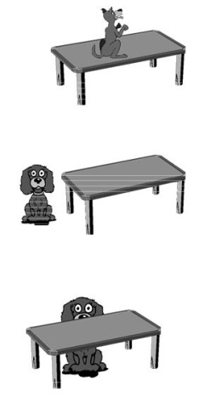
- The dog is the table.

- The dog is the table.

- The dog is the table.
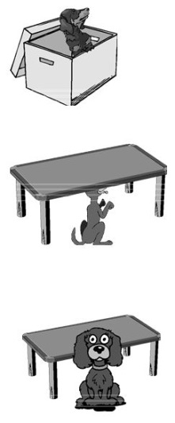
- The dog is the box

- The dog is the table.

- The dog is the table.

- What time is it? Write the correct time next to the clock. Koliko je ura. Odgovor zapiši v celi povedi.

1___________________________ 2 __________________________
3__________________________ 4___________________________ 5______________________________ 6___________________________  7_____________________________

- What's the time? Click on the link below and practise.
Koliko je ura? Klikni na spodnjo povezavo in vadi.

https://learnenglishkids.britishcouncil.org/es/node/18105

- Read the text.
Preberi besedilo.

Hello! My name is Linda Minogue. I’m Australian. I have got two sisters and five brothers. I live with my parents in Sidney, a beautiful city near the ocean.
Our family is quite big. I have got three grandparents. On my father’s side I have only got one grandmother. She lives in my house. She is very old. She is eighty-five years old. Her birthday is on 11th July. She has got short curly white hair.
I have got four uncles, seven aunts and twenty-five cousins. I love our birthdays and Christmas. We make great parties for all the family.
Today I am in Portugal on holiday. I am here with my husband and my two daughters. We love Portugal.




4a) Mark the sentences as True (T ) or False (F ). / Označi trditve (T ) ali False (F ).
( T ) ( F )
- Her name is Tracy
- She lives in Portugal.
- She has got 35 cousins.
- She is from Australia.
- Today she is in Portugal with her father.
4b) Complete the sentences. / Smiselno dopolni povedi.
a. Linda has got _________________sisters and five ______________________.
b. She lives in __________________, in a city called ______________________.
c. Her grandmother ____________________________ years old.
d. Linda _________________________ two daughters.
4c) Complete the text about Jane, Linda’s cousin, with the verbs to be (am, is, are) and to have got. / Dopolni besedilo o Jane, Lindini sestrični, s pravilnimi oblikami glagolov to be (am, is, are) in to have got.

Hi! My name _____________Jane Minogue. I ____________ Australian and I _____________ twenty-two years old. I _____________ 1.75 m tall and I ____________ very tall for a woman. I _____________ long brown hair and my eyes _____________ green. I ______________ very long legs.
I _____________ a student at the University.
I live with my parents in a lovely house. The house _______________ a big garden with some trees.
My mother ______________ tall like me and she _______________ long legs too.

EXTRA – DODATNA NALOGA

- Describe your favourite person.
Opiši svojo najljubšo osebo. Pomagaj si z nalogo 4 in besedami iz spodnjega okvirčka.
old young short tall fat thin/slim dark blonde curly long bald beard beautiful handsome kind clever naughty intelligent funny
tall bald straight pretty handsome slim

Rešitve: 1 on, 2 next to, 3 behind, 4 in, 5 under, 6 in front of
Rešitve: 1 It's five to nine. 2 It's a quarter past ten. 3 It's half past eight. 4 It's a quarter to one. 5 It's ten past three. 6 It's twenty to ten. 7. It's two o'clock.
live = živeti, husband = mož, daughter = hči
Rešitve: F, F, F T, F
Rešitve: two, brothers / Australia, Sidney / is eighty-five / has got
Rešitve: is, am, am, am, am, have got, are, have got, am, has got, is, has got
Dodatna naloga je neobvezna. Lahko jo narediš tudi kot »domačo nalogo«.

