REVISION – FAMILY, BODY AND she/he/I & is/has got

- FAMILY MEMBERS &TREE. Click on the link. Listen and repeat the words.
Klikni na spodnjo povezavo. Poslušaj in ponovi besede.
https://www.youtube.com/watch?v=FHaObkHEkHQ

- Read the letter and do the exercise.
Preberi pismo in dopolni povedi.
From: kellycali@ainrofilac.eg
To: yoko@idkwyl.ptm
Subject: My family
Dear Yoko
Let me tell you about my family. I live with my mum, my dad and my big sister. We live in California. My mum’s name is Carmen. She’s Mexican and she speaks English and Spanish. She’s a Spanish teacher. She’s short and slim, she’s got long, brown hair and brown eyes. My dad’s name is David. He’s American. He’s tall and a little fat! He’s got short brown hair and blue eyes. He works in a bank. My sister Shania is 14 and she loves listening to music. She listens to music all the time! She’s got long brown hair and green eyes, like me. I’ve got long hair too. We’ve got a pet dog, Brandy. He’s black and white and very friendly.
Write soon and tell me about your family.
Love
Kelly

1. I live with my mum, my dad and my big _________.  2. My mum's name is ______________.  3. She's got long brown ____________ and __________ eyes.  4. My dad is tall and a little fat. He works in a __________.  5. My sister Shania is ____________ years old.  6. We've got a _____________dog. | CARMEN  PET  BROWN  BANK  SISTER  HAIR  FOURTEEN
- Read about Kate and fill in the gaps. Mind the family tree.
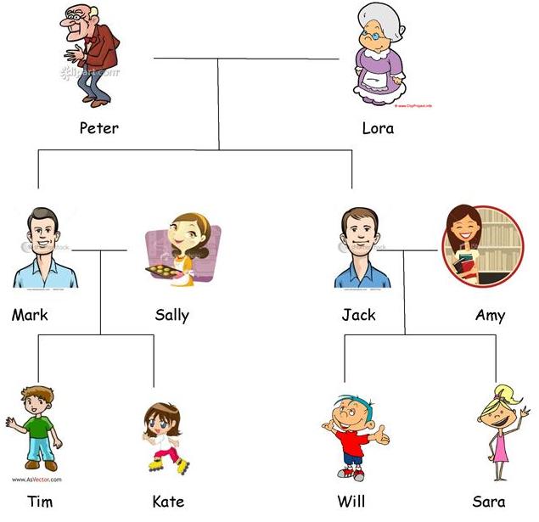
Preberi o Kate in njeni družini ter dopolni povedi. Pomagaj si z družinskim drevesom na desni.
My name is Kate. I am nine. On the right you can see my family tree.
My ¹_________'s name is Tim. He is ten years old. Sally is my ²________. She likes baking. My dad is ³___________. He is tall and strong. My dad's brother is Jack. Jack is my ⁴_____________. He is married to Amy. My favourite people in my mamily are the oldest, my ⁵_____________ Peter is 80 and my grandma ⁶____________ is 79 years old. I like playing with my two ⁷__________, Will and Sara.

- Read about Kate again and fill in the gaps with I/HE/SHE.
Preberi o Kate in njeni družini ter dopolni povedi. Vstavi HE, SHE, I.

My name is Kate. ¹_____ am nine. Above you can see my family tree.
My brother's name is Tim. ²______ is ten years old. Sally is my mother. ³______ likes baking. My dad is Mark. ⁴______ is tall and strong. My dad's brother is Jack. Jack is my uncle. ⁵______ is married to Amy. ⁶______ is my aunt. My favourite people in my mamily are the oldest: My grandpa is Peter. ⁷______ is 80. My grandma is Lora. ⁸_____ is 79 years old. I like playing with my two cousins, Will and Sara.
Če imaš še moč in voljo, se loti še spodnjih dveh nalog. Drugače ju lahko rešiš kasneje. Vzemi to kot angleško domačo nalogo, ki jo boš naredil(a) enkrat v tem tednu.

- Read about my MONSTER.
Preberi o moji pošasti.

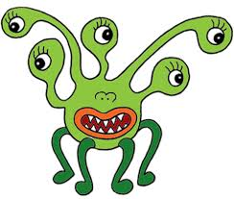
This is my monster. He is a boy. His name is SCARRY. He has got one head but he has got five eyes. His mouth is very big. He has got sharp teeth. He has got a funny nose. He hasn't got any hair. He hasn't got any arms either. But he has got four legs. He is very fast!

- Draw your own MONSTER and describe it.
V zvezek nariši svojo POŠAST in jo opiši po zgornjem zgledu.

POMOČ:

BOY | GIRL
HE - on | SHE - ona
HE IS – on je | SHE IS – ona je
HE HAS GOT – on ima | SHE HAS GOT – ona ima
HE HASN'T GOT – on nima | SHE HASN'T GOT – ona nima
HIS – njegov(a, o) | HER – njen(a, o)

Rešitve: 1.sister 2. Carmen 3. hair, brown 4. bank 5. fourteen 6. pet
Rešitve: 1.brother 2. mum/mother 3. Mark 4. uncle 5. grandpa/grandfather 6. Lora 7. cousins
Rešitve: 1. I 2. He 3. She 4. He 5. He 6. She 7. He 8. She
V zvezku najdeš zapis delov telesa.

