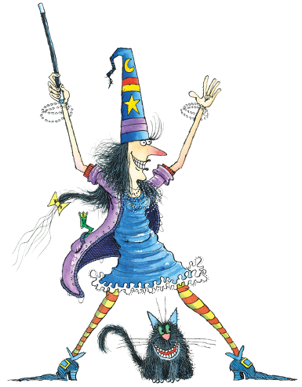
REVISION – WINNIE IN WINTER

- Click on the link below. Listen and read the story.
Klikni na spodnjo povezavo. Poslušaj in beri zgodbo.

https://www.youtube.com/watch?v=QZNLatGX0ms

- Click on the link below. Sing the song.
Klikni na spodnjo povezavo. Zapoj.

https://www.youtube.com/watch?v=0KvDF4F5GYw

- Vocabulary. Translate.
Preveri znanje besedišča. Prevedi.

 | ENGLISH | SLOVENE
1 | a witch
2 | a cat
3 | a tail
4 | winter
5 | book of spells
6 | a hat
7 | a coat
8 | gloves
9 | a scarf
10 | on tiptoes
11 | eyes
12 | wand
13 | summer
14 | people
15 | party
16 | animals
17 | flowers
18 | clothes
19 | hot chocolate
20 | cosy
- Put the words in the right order and write the sentences on the lines.
Iz danih besed tvori povedi.
a) Winnie and / winter / Wilbur / didn't like
________________________________________________________
b) her clothes / put on / Winnie / outside / and went
________________________________________________________
c) ABRACADABRA / shouted / she / disappeared / and snow
________________________________________________________
d) summer / animals / didn't like / and flowers
________________________________________________________
e) came / to her garden / many people / partying/ and started
________________________________________________________________________________________________________________________
f) very angry / Winnie / was
____________________________________________________________
g) again / she / her wand / took / her magic spell / and did
________________________________________________________________________________________________________________________
h) rushed / people / back home
____________________________________________________________

i)went / back to sleep / animals and flowers
____________________________________________________________

j) went / Winnie and Wilbur / to bed / where / nice and warm / it was
________________________________________________________________________________________________________________________

Rešitve: 1 čarovnica 2 mačka 3 rep 4 zima 5 knjiga urokov 6 klobuk 7 plašč 8 rokavice 9 šal 10 po / na prstih 11 oči 12 čarobna palica 13 poletje 14 ljudje 15 zabava 16 živali 17 rože 18 oblačila 19 vroča čokolada 20 udoben
Rešitve: a) Winnie and Wilbur didn't like winter. b) Winnie put on her clothes and went outside. c) She shouted ABRACADABRA and snow disappeared. d) Animals and flowers didn't like summer. e) Many people came to her garden and started partying. f) Winnie was very angry. g) She took her wand and did her magic spell again. h) People rushed back home. i) Animals and flowers went back to sleep. j) Winnie and Wilbur went to bed where it was nice and warm.

