6. C – ENGLISH: 1st June – 2nd June, 2020

UNIT 4 – 4. enota
What are you doing? – Kaj počneš?


- DEL
No, pa malce ponovimo snov prejšnjega tedna 😊 Reši nalogi spodaj, lahko si pomagaš z zvezkom!

Object Pronouns Practice
- Zamenjaj podčrtane besede z osebnim zaimkom v 3. ali 4. sklonu. Prvi primer imaš že rešen.

- The teacher always gives the students homework. THEM
- Sally is going to see Anne.
- My father is writing a letter to John.
- I don't know the answer.
- I am reading the book to my little sister.
- The boys are riding their bikes.
- Open the window, please.
- Can you tell the people the way to the airport, please?
- The books are for Peter.
- Can you help my sister and me, please?

- Osebni in predmetni zaimki. Besede v debelem tisku nadomesti z ustreznimi osebnimi oziroma predmetnimi zaimki.

- Helen is friends with Jim. ________________________________________________
- Carol and I like roses. ___________________________________________________
- John knows Tim. ______________________________________________________
- Tom and Tony work together with Mary. ___________________________________
- This present is for Veronica and Tina. _____________________________________
My two sisters don't like your uncle. ______________________________________

- DEL

Ali si sedaj, ko si doma v karanteni, veliko govoril-a po telefonu s prijatelji? 😊
Odpri učbenik na str. 116, poslušaj in beri pogovor, nato pa ga zaigraj z enim od družinskih članov. 😊
Posnetek najdeš na: http://www.e-gradiva.com/dokumenti/T6/P/U4A3.mp3
Posnetek poslušaj večkrat, da boš dobro slišal-a izgovorjavo.

Preberi spodnje povedi in vse skupaj zapiši ali natisni ter prilepi v zvezek.

TB p.116 A3 What are you doing?

What are you doing? – Kaj počneš (ta trenutek)?
I'm (having a shower). / I'm (watching TV). – Tako poveš, kaj pravkar, v tem trenutku počneš.
This is (Jane) speaking. / It's (Jane). – Tako se predstaviš po telefonu.
Can I speak to (John)? – Tako vprašaš, če lahko govoriš z nekom.
Can he call back later? – Ali lahko pokliče nazaj kasneje?
She can't come to the phone. – Ona ne more priti k telefonu.

Ali si v zapisanem besedilu v UČB opazil kaj novega? Osredotoči se na: ROY IS SPEAKING, SHE'S HAVING, WHAT ARE YOU DOING?
Kaj opaziš? Končnico ING ter IS in ARE. Takšno obliko uporabljamo, ko govorimo o tem, kaj se PRAVKAR DOGAJA, torej sedaj, v tem trenutku.
Angleškemu času, ki ima to obliko, rečemo PRESENT CONTINUOUS TENSE.
Oglej si spodnjo razpredelnico, večkrat jo preberi. Nato jo natisni in prilepi v zvezek.

THE PRESENT CONTINUOUS TENSE – OPISNI SEDANJI ČAS

Ta čas uporabljamo, ko govorimo o tem, kaj počnemo ta trenutek.
TVORBA: glagolu dodamo končnico -ING
1. Trdilna oblika
I | am travelling.  'm driving a car.
You  We  They | are having a shower.  're changing.
He  She  It | is sitting in the garden.  's playing with my dog.

2. Nikalna oblika
I | am not travelling.  'm not driving a car.
You  We  They | are not having a shower.  aren't changing.
He  She  It | is not sitting in the garden.  isn't playing with my dog.

3. Vprašalna oblika
Am | I travelling?  driving a car?
Are | you having a shower?  we changing?  they
Is | he sitting in the garden?  she playing with my dog?  it

4. Short answers:
Yes, I am. No, I'm not.
Yes, you are. No, you're not.
Yes, he/she/it is. No, he/she/it isn't.

Pri nekaterih glagolih pride do sprememb, ko jim dodamo končnico –ING:

Ko glagolom, ki se končajo na –e, dodamo končnico –ing, -e odpade:

have → having dance → dancing
shake → shaking write → writing
type → typing live → living

Nekateri glagoli podvojijo soglasnik pred končnico –ing:
shop→ shopping
sit → sitting
get → getting
stop → stopping
travel→travelling (obstaja tudi ameriška različica traveling)

Zelo posebna sta glagola lie (ležati, lagati) in die (umreti). Ko jima dodamo končnico –ing, se
-ie spremeni v –y:

lie + ing → lying die + ing → dying

Sedaj si pa oglej posnetek, s katerim boš lažje razumel novo snov ter se še malce nasmejal. 😊 Obljubim ti, da ti ne bo žal! https://www.youtube.com/watch?v=o4X8PIMs344

Oglej si slike v UČB na str. 117, vaja 2. What are they doing? Kaj počnejo? Dopolni vprašanja z IS in ARE.

V DZ reši naloge 14, 15 in 16 na str. 109 in 110. Pomagaj si z razpredelnico v zvezku.

Congratulations! You have done everything for this week! WELL DONE!
Na zadnji strani imaš rešitve nalog v DZ, ko naloge opraviš, jih podrobno preglej. See you on Wednesday this week,
Your teacher DKoprivšek


Rešitve vaj v zvezku, UČBENIKU IN DZ

ZVEZEK
- The teacher always gives the students homework. THEM
- Sally is going to see Anne. HER
- My father is writing a letter to John. HIM
- I don't know the answer. IT
- I am reading the book to my little sister. HER
- The boys are riding their bikes. THEM
- Open the window, please. IT
- Can you tell the people the way to the airport, please? THEM
- The books are for Peter. HIM
- Can you help my sister and me, please? US

- Osebni in predmetni zaimki. Besede v debelem tisku nadomesti z ustreznimi osebnimi oziroma predmetnimi zaimki.

- Helen is friends with Jim. SHE….HIM____
- Carol and I like roses. _WE…..THEM____
- John knows Tim. HE…HIM
- Tom and Tony work together with Mary. _THEY ….HER__
- This present is for Veronica and Tina. _IT…THEM_
My two sisters don't like your uncle. THEY….HIM

UČBENIK
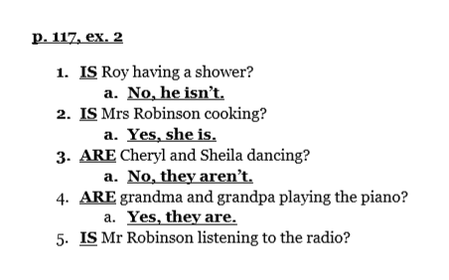
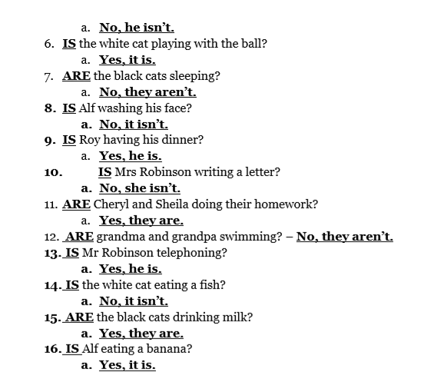

DELOVNI ZVEZEK
