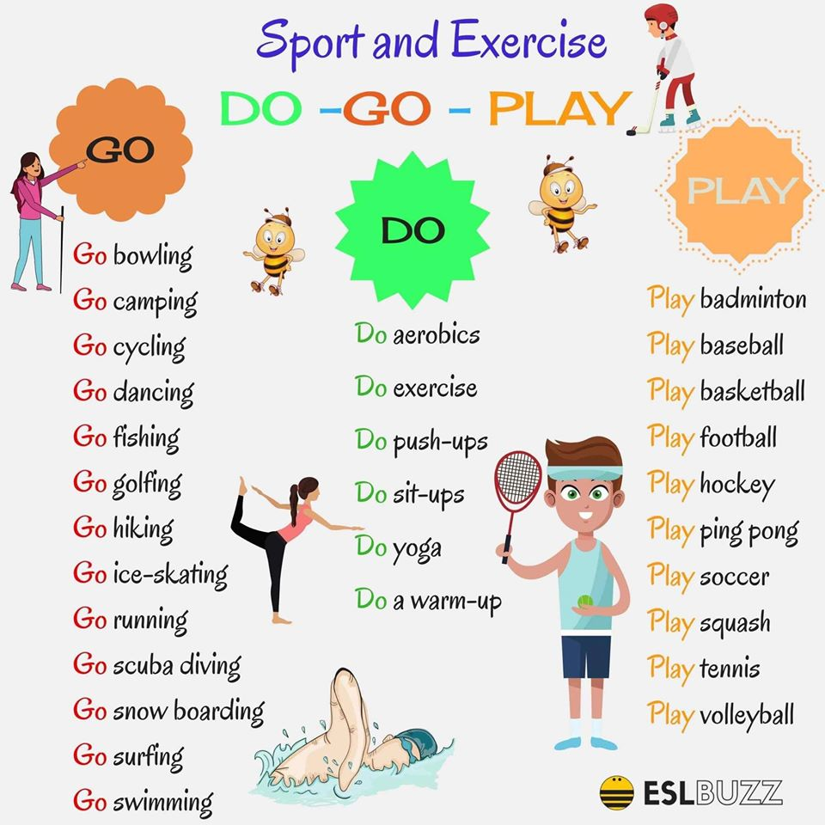

Practise! Vadi.
https://www.englishexercises.org/makeagame/viewgame.asp?id=7821

Učiteljica B

