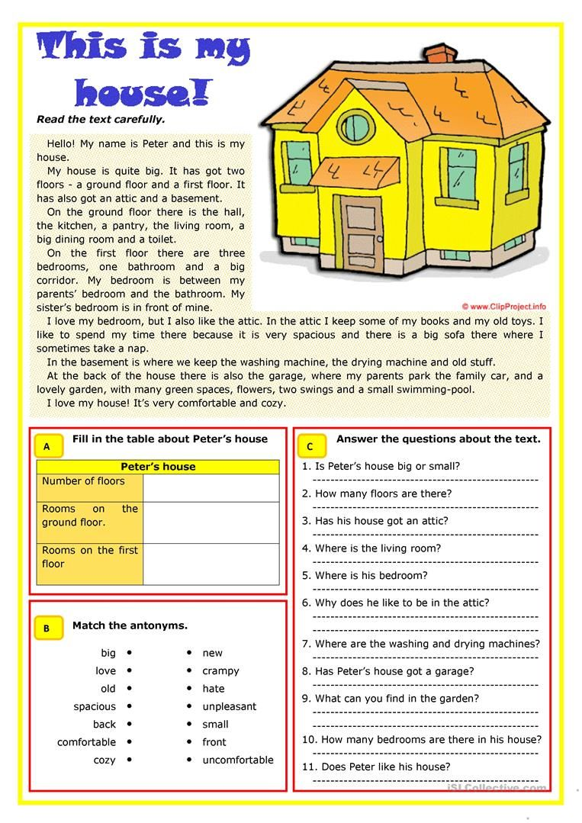

PRIMER OPISA STANOVANJA :
My flat is big. There are two bedrooms, a kitchen, a dining room, a big living room and a bathroom with the toilette. There is a small hall. There is a balcony, too. A living room is big and sunny. There is a big sofa in the living room. I like my bedroom. It’s very nice. There are two windows.

PRIMER OPISA SANJSKE HIŠE:
My dream house is a big house in the mountains. It has a big living-room with a home theatre for watching movies and playing video games. There is also an enormous garden with a swimming pool and lots of flowers and plants. I like nature and the outdoors. There are many bedrooms so all my friends can visit me and stay over. There is also a stable with horses so we can go horse-riding in the mountains. It has solar panels on the roof to provide electricity and an electric car to shopping in the nearby town.

Pomagajte si z zgornjimi opisi in opišite svojo stanovanje ali hišo.
Opis mi pošljite do 10.6. na mail.
Vaša učiteljica Bernarda

