TEST PAPER 1 CLASS 9
Name: |  |  | 0 - 43,5 | 1 (nzd)
Class: |  |  | 44 - 59,5 | 2 (zd)
Date: |  |  | 60 - 74 | 3 (db)
Points: |  |  | 74,5 - 87,5 | 4 (pdb)
Grade: |  |  | 88 - 98 | 5 (odl)

1. Complete. Obkroži ustrezno besedo. | /10

1. Vasco da Gama was the first European that reached India by ____.
a) sail b) colony c) sea

2. Some people aren’t convinced that our planet is ____ and want to prove that it’s flat.
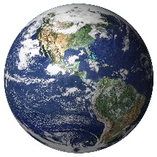
a) spherical b) globe c) circle

3. Cinnamon, pepper and nutmeg were traded along the Spice ____ .
a) highway b) trail c) road

4. The Northern American states were against ____ .
a) slavery b) cerf c) master

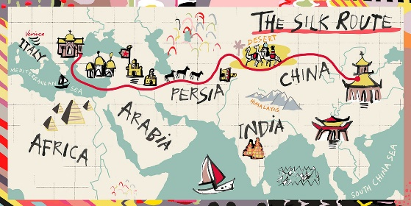
5. The ____ to India were very long and exhausting.
a) journal b) voyages c) journey

6. Knights fought on ____ in the Middle Ages.
a) bike b) horseback c) railway

7. ____ were the lowest social class of the feudal society.
a) Serfs b) Peasant c) Lords

8. The Silk Route was important for ____ between China and the Mediterranean.
a) sailor b) trading c) shop

9. The Dutch established the first ____ on Manhattan Island.
a) settled b) settler c) settlement

10. Medieval peasants made the goods in ____ for protection.
a) barter b) cash c) exchange

2. Match. Smiselno poveži dele stavkov. Zapiši ustrezno številko. | /10
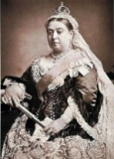
1. | Medieval life was based on |  | from Cuba to the United States in 1839.
2. | 'The Patriot' is a story of America's fight |  | the scarlet letter A.
3. | Hester’s punishment is to wear a symbol of her sin - |  | is celebrated on the 5th of November.
4. | The French and the British colonised |  | invaded England.
5. | 'La Amistad' was a slave ship that travelled |  | prehistoric monuments.
6. | Victoria became queen of the UK |  | was fought in 1066.
7. | Stonehenge is one of the world’s most famous |  | the feudal system.
8. | Guy Fawkes night |  | for independence from British rule.
9. | The Anglo-Saxons |  | at the age of eighteen.
10. | The Battle of Hastings |  | most of North America.

3. Read the text, then do the following tasks. Preberi besedilo in reši naloge A, B in C.

A) True, false or not given? Drži, ne drži ali ni v besedilu? Ustrezno obkroži. | /4

1. Virginia was the first British colony established in North America. | T | F | NG
2. ‘Boston Tea Party’ took place more than three hundred years ago. | T | F | NG
3. The colonists got rid of all the tea on board. | T | F | NG
4. Today's flag has the same number of stripes as the original American flag. | T | F | NG

B) Give short answers. Napiši kratke odgovore. | /4

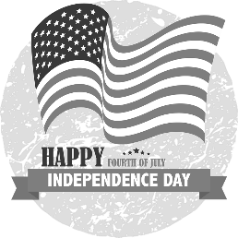
1. Were the American colonies independent in the first half of the 18th century? _______________________________________________________
2. What year was the Declaration of Independence written?
_______________________________________________________
3. Who helped the Americans in the fight for the independence? _______________________________________________________
4. What are the names for the flag of the USA?
_______________________________________________________

C) Find the synonyms in the text. V besedilu poišči sopomenke. | /4
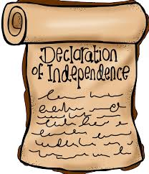
1. | established | (adj)
2. | start | (verb)
3. | warriors | (noun)
4. | stand for | (verb)

4. Complete the text. Dopolni besedilo z manjkajočimi besedami. | /10

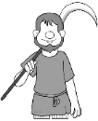
Life was hard for the peasants in the medieval era. The only time they could enjoy themselves was at the tournaments or at church f______________. These events were held quite often and paid by the lord of the m_______________. Money didn’t exit there so everything was paid in b_________________.
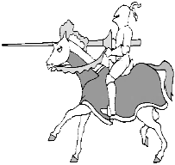
A knight had to learn how to fight and so serve the lord according to the Code of Chivalry. Knights often attended tournaments. The main activities were the j________________ and the melee. Each contestant wore an armour, a s__________________ and a h______________ for protection. The tournaments attracted a lot of spectators, not only the nobles but also the c____________________, the ordinary people.
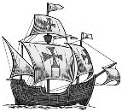
Many explorers wanted to find a shorter r____________________ to India. Columbus thought that the Earth was r____________________ and that sailing west would get him straight to India. He didn’t know that a huge c___________________was in the way, so he eventually landed on a Bahama island and named it San Salvador.

5. Complete the text using the verbs in the Past Simple. Dopolni besedilo z glagoli v pretekliku. | /10

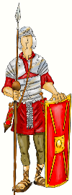
The Romans ____________________ (rule) the biggest empire the world had ever seen. At its peak it ____________________ (stretch) from Egypt to Germany. In 43AD they ____________________ (land) in southern Britain. Around 80AD they ____________________ (decide) to conquer Scotland as well. The Roman invasion of Scotland was led by General Agricola in 81AD. His troops marched northwards, building roads so that they ____________________ (can) travel quickly, and camps and forts from which they could control the countryside. Celtic chiefs and warriors ____________________ (fight) back against the invaders but were no match for the Roman army. In just two years the Romans ___________________ (conquer) most of Scotland south of the river Tay. To mark the limit of the land they controlled and keep out invaders from the north, the Romans ____________________ (build) a huge frontier barrier – Hadrian’s Wall. Work ____________________ (begin) in 122AD in the reign of the emperor Hadrian. The Wall ____________________ (run) right across Britain from east to west.

6. Use the Past Simple or Continuous. Uporabi navadni ali opisni preteklik. | /10

Last night I _________________ (sit) in a café when I _________________ (notice) a sports car running very fast towards a red light. I looked at the driver and I ________________ (see) that he __________________ (talk) on the phone. I _________________ (think) he would stop but he didn’t. He _________________ (not/try) to stop at all. Luckily the other cars _________________ (stop). The sports car crashed into a tree. When the police arrived, the officer asked me: “What __________________ (happen)?” “The driver __________________ (not/see) the traffic light because he __________________ (use) the phone while driving,” I answered.

7. Make questions. Zapiši vprašanja za podčrtane dele povedi. | /10

The sailors were having dinner, when the ship suddenly hit the coral reef. ______________________________________________________________________________________
Henry VIII had eight wives.
______________________________________________________________________________________
The Romans invaded Britain.
_________________________________________________ _____________________________________
The Silk Road went from China to Eastern Europe. ______________________________________________________________________________________
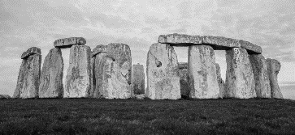
Bronze Age people built Stonehenge. ______________________________________________________________________________________

8. Complete the text using the words from the box. Dopolni z besedami iz okvirčka. 2 sta odveč. | /10

their  kayak | be  with | lord  been | preserve  facilities | since  customs | arrival  ranges
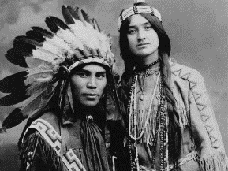
During the thousand years prior to the ____________________ of the first Europeans, dozens of ‘Indian’ cities flourished throughout what is now the USA. The tribes had their own languages and ____________________. The white man took many of their inventions as gifts of survival and pleasure: the canoe, ____________________, smoking pipe, dog sledges and parka. Almost half the American states have names borrowed from the natives, as well as a lot of cities, rivers, towns, lakes and mountain ____________________.
____________________ the end of bloody conflicts between the Indians and the white man a century ago, most Indians have lived in poverty on reservations. The white people have always controlled life on about 300 reservations across the country, and Indians have never liked this outside control. There have ___________________ many protests and demonstrations.
Some tribes have become extinct, but a considerable number have managed to ____________________ their identity and unique lifestyle. Many tribes provide extensive tourism ____________________. They have built resort hotels, arts and craft galleries, museums, and recreation centres as well as casinos and bingo halls. The income from tourism and gambling allows Native Americans to _________________ themselves – to create their own crafts, do their dances, speak their language, wear their costumes, and display ____________________ identity with self-respect and self-esteem.

9. Complete the chart. Dopolni razpredelnico. | /6

INFINITIVE | PAST TENSE | PAST PARTICIPLE | TRANSLATION
say
 | spoke
 |  | swum
 |  |  | pisati

10. Write down your ancestor’s story. Babica ti je povedala zgodbo o tvojem predniku, ki se je pridružil Kolumbovi odpravi. Opiši njegovo življenje pred odhodom, njegovo bivanje na ladji ter odkritje nove celine. Napiši, kaj mu je bilo všeč in kaj ne. | /10
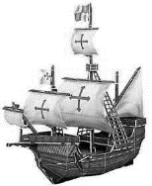
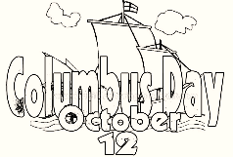

...............................................................................................................
...............................................................................................................
...............................................................................................................
...............................................................................................................
...............................................................................................................
...............................................................................................................
...............................................................................................................
...............................................................................................................
...............................................................................................................
...............................................................................................................
...............................................................................................................
...............................................................................................................
...............................................................................................................
...............................................................................................................
...............................................................................................................
...............................................................................................................

...............................................................................................................
...............................................................................................................
...............................................................................................................
...............................................................................................................
...............................................................................................................
...............................................................................................................
...............................................................................................................
...............................................................................................................
...............................................................................................................
...............................................................................................................
...............................................................................................................
...............................................................................................................
...............................................................................................................
...............................................................................................................
...............................................................................................................
...............................................................................................................
The first British colony in North America was Virginia, set up in 1607. By 1750, there were 13 colonies. In the beginning, the colonists got along with the Native Americans. Then, as the colonies grew, relations became worse and fighting broke out. In the end, the Natives were forced to move west.
In the mid-1700s, American colonies grew tired of the British rulers because Britain imposed new taxes on the colonies, including a tax on tea. In 1773 colonists boarded British ships and tossed the tea overboard. This event is known as 'Boston Tea Party'.
In 1776 the colonies wrote the Declaration of Independence, which said they should be free from British rule. After several battles, France sent soldiers to help the colonists fight the British. In 1781 the British army was defeated. The colonies signed a constitution agreeing to become independent states, ruled by a central government. The USA was born and George Washington was elected as its first president.
The first American flag had thirteen stars and thirteen stripes – one for each of the 13 colonies. Today the flag consists of thirteen stripes bearing fifty stars that represent the fifty states of the USA. Nicknames for the flag include 'The Stars and Stripes', 'Old Glory', and 'The Star-Spangled Banner'.

The first British colony in North America was Virginia, set up in 1607. By 1750, there were 13 colonies. In the beginning, the colonists got along with the Native Americans. Then, as the colonies grew, relations became worse and fighting broke out. In the end, the Natives were forced to move west.
In the mid-1700s, American colonies grew tired of the British rulers because Britain imposed new taxes on the colonies, including a tax on tea. In 1773 colonists boarded British ships and tossed the tea overboard. This event is known as 'Boston Tea Party'.
In 1776 the colonies wrote the Declaration of Independence, which said they should be free from British rule. After several battles, France sent soldiers to help the colonists fight the British. In 1781 the British army was defeated. The colonies signed a constitution agreeing to become independent states, ruled by a central government. The USA was born and George Washington was elected as its first president.
The first American flag had thirteen stars and thirteen stripes – one for each of the 13 colonies. Today the flag consists of thirteen stripes bearing fifty stars that represent the fifty states of the USA. Nicknames for the flag include 'The Stars and Stripes', 'Old Glory', and 'The Star-Spangled Banner'.

The first British colony in North America was Virginia, set up in 1607. By 1750, there were 13 colonies. In the beginning, the colonists got along with the Native Americans. Then, as the colonies grew, relations became worse and fighting broke out. In the end, the Natives were forced to move west.
In the mid-1700s, American colonies grew tired of the British rulers because Britain imposed new taxes on the colonies, including a tax on tea. In 1773 colonists boarded British ships and tossed the tea overboard. This event is known as 'Boston Tea Party'.
In 1776 the colonies wrote the Declaration of Independence, which said they should be free from British rule. After several battles, France sent soldiers to help the colonists fight the British. In 1781 the British army was defeated. The colonies signed a constitution agreeing to become independent states, ruled by a central government. The USA was born and George Washington was elected as its first president.
The first American flag had thirteen stars and thirteen stripes – one for each of the 13 colonies. Today the flag consists of thirteen stripes bearing fifty stars that represent the fifty states of the USA. Nicknames for the flag include 'The Stars and Stripes', 'Old Glory', and 'The Star-Spangled Banner'.

