1 Glej slike in dopolni besedilo s spodnjimi glagoli v preteklem času Past Simple.

be (2x), fall, take, begin, stop, see, can, arrive, rescue, thank, give

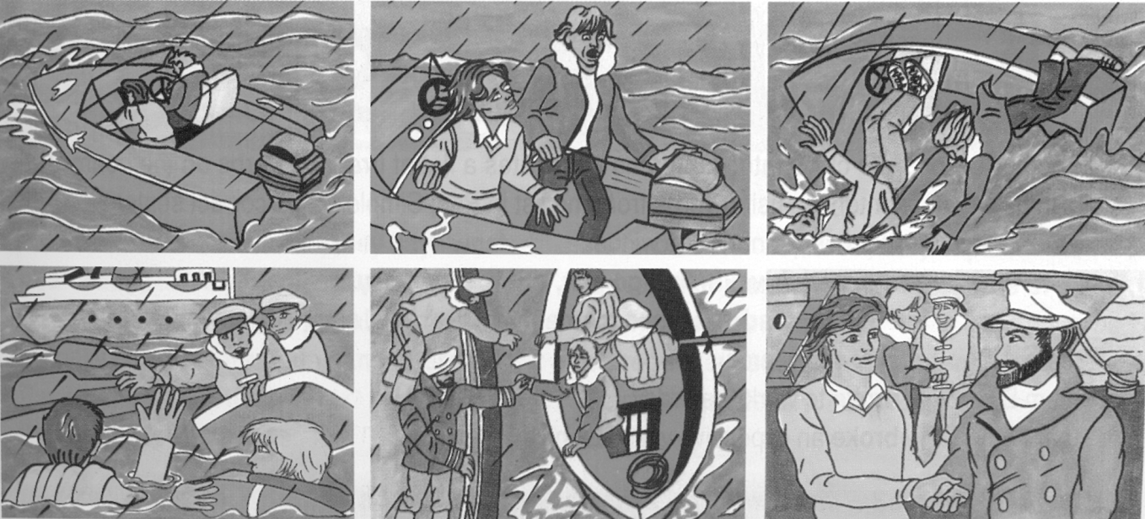

Two men ______________ at sea in a small boat. It ___________ to rain and the sea became very rough. Suddenly the engine ______________. The men tried to repair it but they ____________ (not) start it again. Then a huge wave crashed against the boat and the two men ______________ into the cold sea. Luckily there _________ a big ship nearby and the captain ________________ the two men. He immediately told some of his crew to get a lifeboat and save the men. The crew in the lifeboat ______________ the two men and ___________ them onto their ship. One of the crew _________________ the men blankets and made them hot drinks. When they ________________ at the harbour the two men _______________ the captain of the ship and his crew for saving their lives.

2 Kaj so delali (oz.niso delali) včeraj ob osmih? Napiši 4 različne stavke (2 trdilna in 2 nikalna).

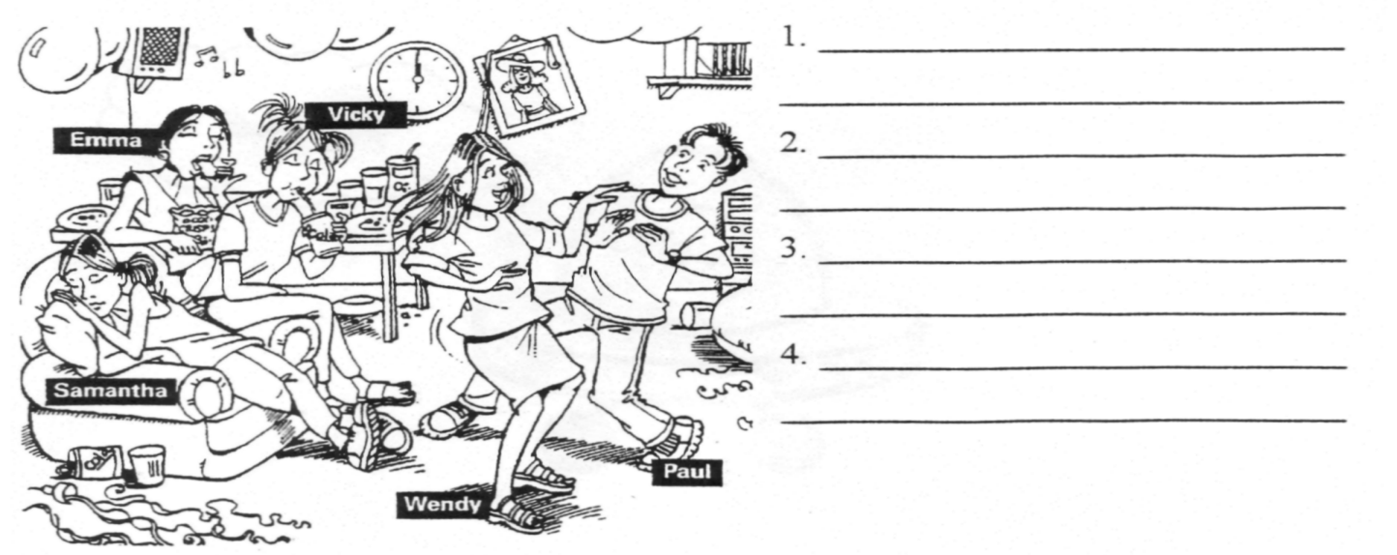

3 Obkroži ustrezen pretekli čas.

1 At 6.15, when you phoned, I had / was having a bath.
2 Bill watched / was watching TV when Ann came in.
3 They got married while they studied / were studying at London University.
4 Yesterday we drove / were driving from Oxford to Edinburgh and back.
5 It was a nice evening, so she walked / was walking home from work.
6 At eight o'clock in the morning Mr. Smith swam / was swimming in the lake.

4 Glagole v oklepajih postavi v ustrezen pretekli čas.

1 While I __________________ (walk) down the road, I __________________ (see) Richard.
2 When Mary __________________ (get) home, she __________________ (make) a cottage pie
for dinner.
3 We __________________ (meet) a lot of interesting people while we
__________________ (travel) in Egypt.
4 My mum _________________ (prepare) dinner while my dad _________________ (drive) home
from work.
5 When John __________________ (see) me, he __________________ (stop) for a while.
6 While we __________________ (lie) at the beach the children __________________ (build)
sandcastles.

