LET'S BEGIN

THIS IS ME. I AM ______________________.
I AM ______________________.
HIS IS ME

- DRAW. NARIŠI.
GOOD NIGHT.
GOOD EVENING.
GOOD AFTERNOON.
GOOD MORNING.

NICE TO MEET YOU.
(GOOD)BYE.
SEE YOU.
HELLO.

- MATCH. POVEŽI.
SING.
STAND UP.
TURN AROUND.
SIT DOWN.
JUMP.
POINT.

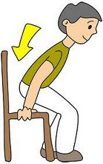
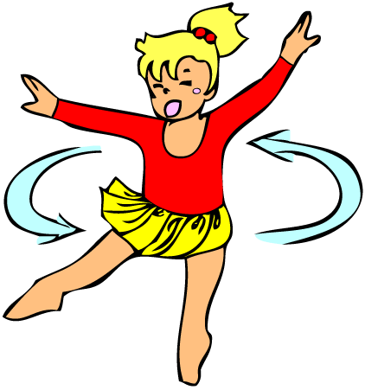
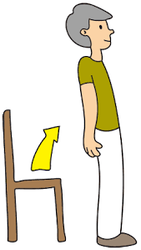
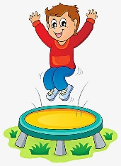
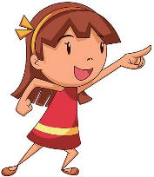


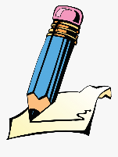

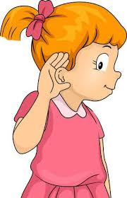
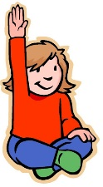
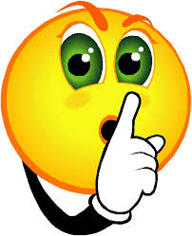

RAISE YOUR HAND.
BE QUIET.
WRITE.
LISTEN.
LOOK.
TOUCH.

CILJI:
- RAZUMEM, POIMENUJEM, UPORABLJAM POZDRAVE IN NAVODILA.
- ZAPOJEM PESMICO THE GREETINGS SONG
- IGRAM SE IGRO SIMON SAYS
- DEKLAMIRAM: POINT TO THE WINDOW, POINT TO THE DOOR, TOUCH YOUR DESK AND SIT ON THE FLOOR. CLEAN THE BOARD, TOUCH THE WALL, SIT ON THE CHAIR, LISTEN, READ, WRITE, DRAW.

- IN THE CLASSROOM – DOPOLNI NA ČRTICE.
IGRAJ SE IGRICO I SPY WITH MY LITTLE EYE.
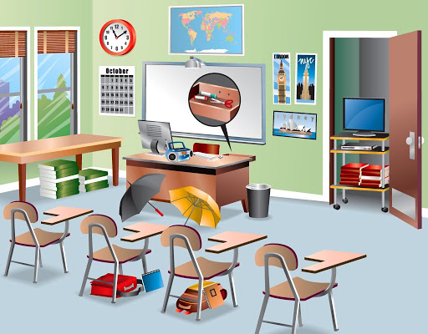
A DOOR A DESK A CHAIR A BOARD FLOOR A WALL
A CLOCK A MAP A COMPUTER A SCHOOLBAG
_ _ _ _ _ _ _ _ _ _
_ _ _ _ _
_ _ _ _ _ _ _ _ _ _ _
_ _ _ _ _ _
_ _ _ _ _
_ _ _ _ _ _
_ _ _ _ _ _
_ _ _ _ _
_ _ _ _
_ _ _ _ _ _ _
_ _ _ _ _ _

- WHAT IS IN MY SCHOOLBAG? KAJ JE V MOJI TORBICI?
THESE ARE …
THIS IS …
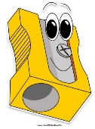
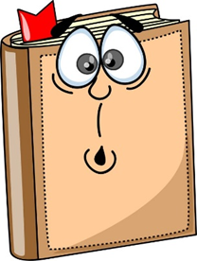
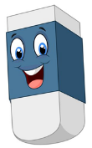
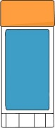
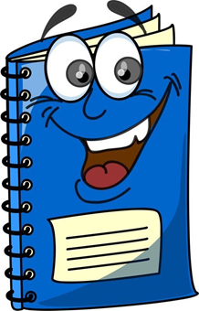
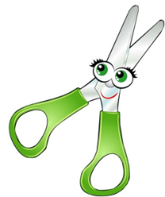
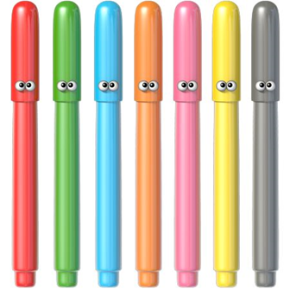
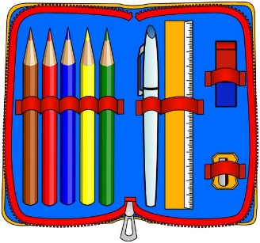

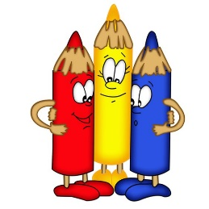

I'VE GOT … A PENCIL, A RUBBER, A GLUE STICK, A PENCIL CASE, SCISSORS, COLOURED PENCILS, FELT-TIP PENS, A PENCIL SHARPENER ETC.

THIS IS ME. I AM ______________________.
I AM ______________________.
HIS IS ME

