SCHOOL

THIS IS ME. I AM ______________________.
I AM ______________________.
HIS IS ME

1. POSLUŠAJ. POBARVAJ PO NAVODILU.
RAINBOW SONG
RED AND YELLOW AND PINK AND GREEN, PURPLE AND ORANGE AND BLUE. I CAN SING A RAINBOW, SING A RAINBOW, SING A RAINBOW, TOO.
LISTEN WITH YOUR HEART, LISTEN WITH YOUR HEART, AND SING EVERYTHING YOU FEEL.
I CAN SING A RAINBOW, SING A RAINBOW, SING A RAINBOW, TOO.
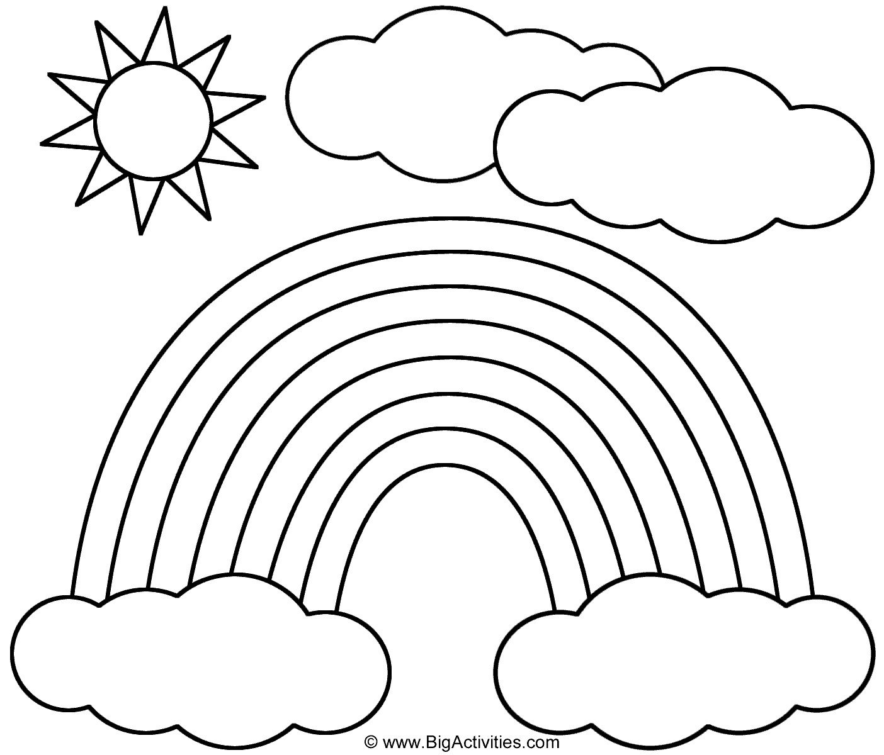


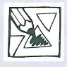

SCISSORS, SCISSORS, CUT, CUT, CUT.
PENCIL, PENCIL,
WRITE, WRITE, WRITE.
NOTEBOOK, NOTEBOOK, OPEN NOW!
COLOURED PENCILS COLOUR WOW!
BOOK, BOOK, BOOK I READ, READ, READ.
FELT-TIP PENS I NEED, NEED, NEED.
GLUE STICK, GLUE STICK,
PASTE, PASTE, PASTE!
PUT YOUR THINGS IN A PENCIL CASE.
2. POSLUŠAJ. POBARVAJ PO NAVODILU.

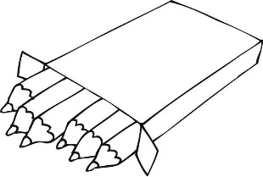
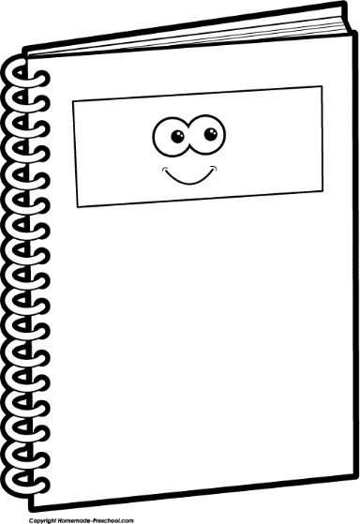

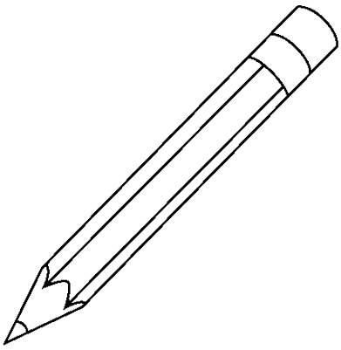
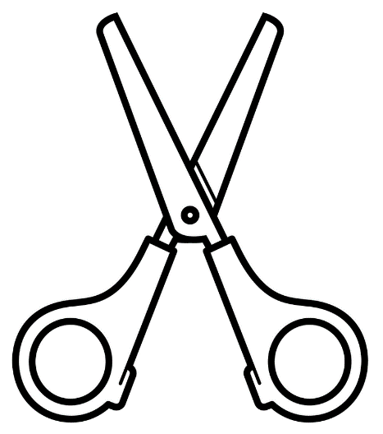

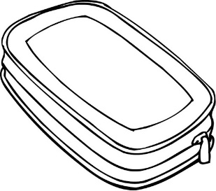

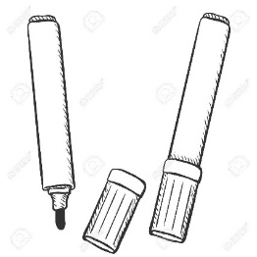
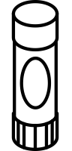

CILJI:
- RAZUMEM, POBARVAM IN POIMENUJEM IZBRANE ŠOLSKE POTREBŠČINE: A PENCIL CASE, A GLUE (STICK), A BOOK, SCISSORS, A NOTEBOOK, A PENCIL, COLOURED PENCILS, FELT-TIP PENS.
- RAZUMEM IN POIMENUJEM BARVE: WHITE, YELLOW, ORANGE, RED, PINK, PURPLE, BLUE, GREEN, GRAY, BROWN, BLACK.
- ZAPOJEM PESMICE RAINBOW SONG, LET'S GO TO SCHOOL; DEKLAMIRAM DEKLAMACIJO O ŠOLSKIH POTREBŠČINAH.

