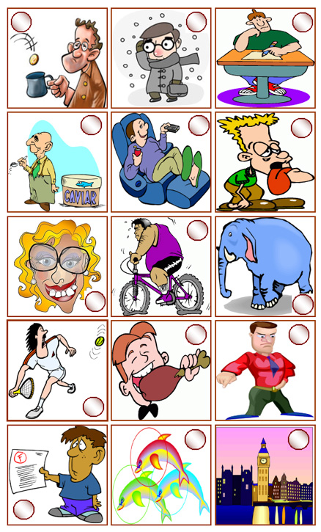
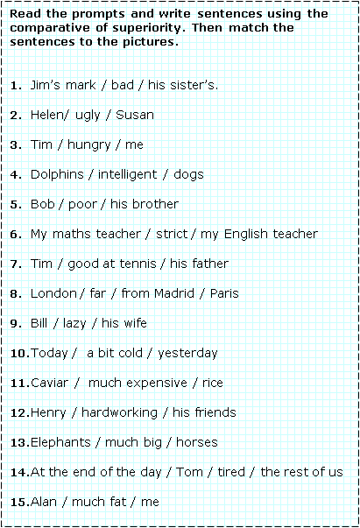
Complete the sentences with the comparative form of the adjectives in brackets + than when necessary.

1.-My house is…………………… from school …….…yours. (far)
2.-This bottle is …………………….………that one. (empty)
3.-I think London is …………………………Oxford. (interesting)
4.-Madrid is much ……………………….…… Santander. (big)
5.-Your father is two years …………………………….mine. (old)
6.-This blue book is ……………………………….…the yellow one. (expensive)
7.-Ben is……………………………….….……you and me. (rich)
8.-The north of Spain is……………………….…the south. (wet)
9.-Diamonds are……………………….…………….……emeralds. (valuable)
10.-The street where I live is much ……..………………….………. yours. (narrow)
11.-He got…………………………………….….…when he found out he had passed the exam. (happy)
12.-My computer is ……………………………….….…my friend’s. (powerful)

The following sentences have mistakes. Spot them and rewrite the sentences in good English.

1.-Laura is as beautiful than Sandra.
……………………………………………………………………….…….
2.-The cinema is more far than the hospital.
……………………………………………………………………….…….
3.-Natalia is more bad at English than me.
……………………………………………………………………….…….
4.-Those grapes are more riper than these.
……………………………………………………………………….…….
5.-Madrid is much crowded than Seville.
……………………………………………………………………….…….
6.-Your cake is much more better than mine.
……………………………………………………………………….…….
7.-Lidia’s son is cleverest than mine.
……………………………………………………………………….…….
8.-This metal box is more heavy than the wooden one.
……………………………………………………………………….…….
9.-My car is more slow than my father’s.
……………………………………………………………………….…….
10.-David is fattest than his brother.
……………………………………………………………………….…….

