AUTUMN

THIS IS ME. I AM ______________________.
I AM ______________________.
HIS IS ME

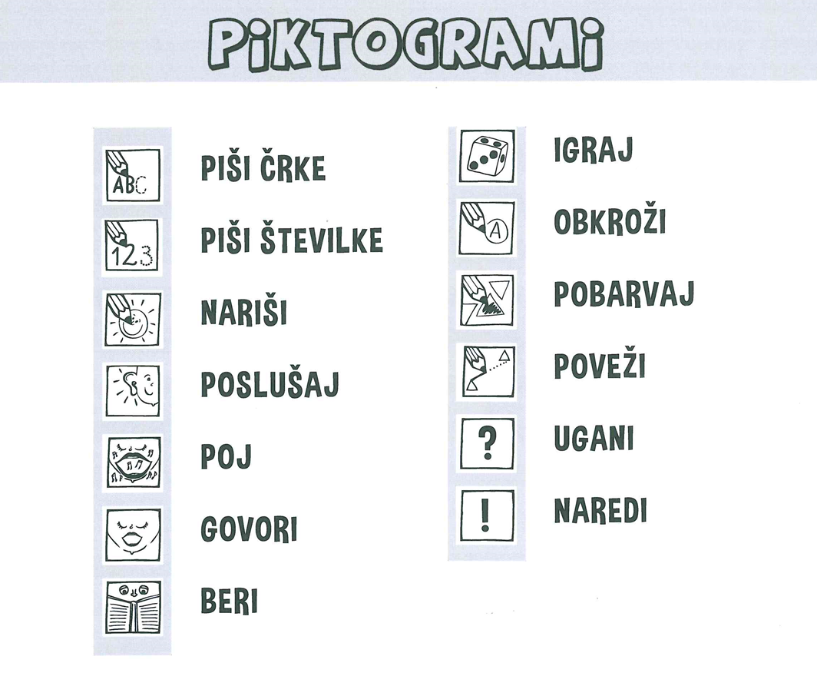
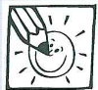
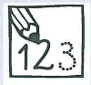
- ONE POTATO, TWO POTATOES. COUNT, DRAW AND SING. PREŠTEJ, NARIŠI IN ZAPOJ.
 | ONE | TWO | THREE | FOUR | FIVE | SIX | SEVEN | MORE
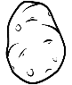
A POTATO
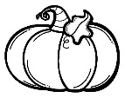
A PUMPKIN
AN APPLE
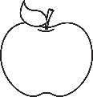
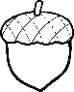
AN ACORN
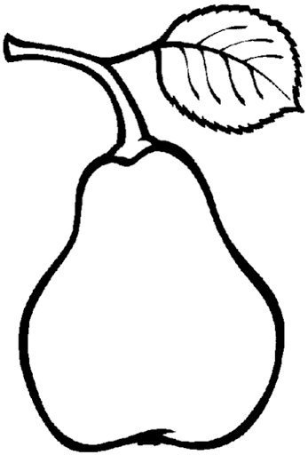
A PEAR

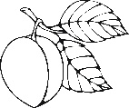
A PLUM
A LEAF

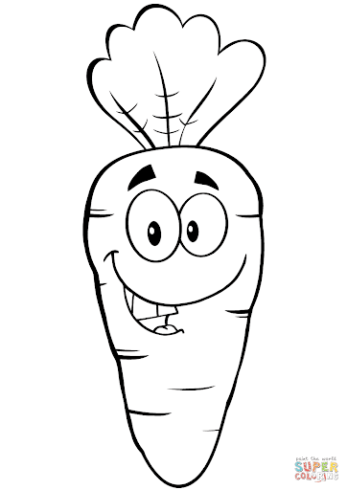
A CARROT

1 POTATO, 2 POTATOES, 3 POTATOES, 4, 5 POTATOES, 6 POTATOES, 7 POTATOES, MORE.
1 PUMPKIN, 2 PUMPKINS, 3 PUMPKINS, 4, 5 PUMPKINS, 6 PUMPKINS, 7 PUMPKINS, MORE.
1 APPLE, 2 APPLES, 3 APPLES, 4, 5 APPLES, 6 APPLES, 7 APPLES, MORE.
1 ACORN, 2 ACORNS, 3 ACORNS, 4, 5 ACORNS, 6 ACORNS, 7 ACORNS, MORE.
1 PEAR, 2 PEARS, 3 PEARS, 4, 5 PEARS, 6 PEARS, 7 PEARS, MORE.
1 PLUM, 2 PLUMS, 3 PLUMS, 4, 5 PLUMS, 6 PLUMS, 7 PLUMS, MORE.
1 LEAF, 2 LEAVES, 3 LEAVES, 4, 5 LEAVES, 6 LEAVES, 7 LEAVES, MORE.
1 CARROT, 2 CARROTS, 3 CARROTS, 4, 5 CARROTS, 6 CARROTS, 7 CARROTS, MORE.

- WHAT DO YOU LIKE TO EAT? KAJ RAD JEŠ? WHAT DO YOU LIKE TO DRINK? KAJ RAD PIJEŠ?
I LIKE TO EAT, EAT, EAT …
I'D LIKE TO EAT, EAT, EAT …
MILK
TEA
JUICE
WATER
I'D LIKE TO DRINK, DRINK, DRINK …
I'D LIKE TO DRINK, DRINK, DRINK …
PIZZA
RICE
STEAK
I'D LIKE TO EAT, EAT, EAT …
I'D LIKE TO EAT, EAT, EAT …
I'D LIKE TO EAT, EAT, EAT …
SOUP
GRAPES
CARROTS
PEARS
PLUMS
I'D LIKE TO EAT, EAT, EAT …
PASTA
POTATOES
APPLES
BANANAS

CILJI:
- ZAPOJEM PESMICI 1 POTATO, 2 POTATOES IN I LIKE TO EAT APPLES AND BANANAS TER NOVE RAZLIČICE.
- ŠTEJEM PRAVILNO DO 7 (RAZLIKUJEM EDNINO IN MNOŽINO).
- POIMENUJEM HRANO IN PIJAČO.
- POVEM, KAJ BI RAD JEDEL IN PIL.

