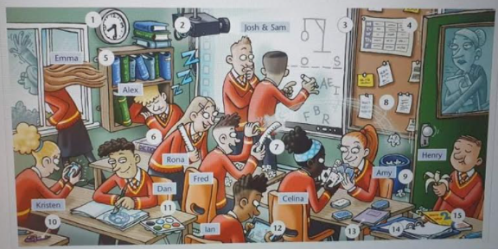
Opis slike – glej zapis iz prejšnjega tedna (9. 11.)

School subjects – šolski predmeti

Maths – matematika
English – angleščina
Geography – geografija
History – zgodovina
Biology – biologija
Science (sajns) – naravoslovje
Art – likovna umetnost
Chemistry – kemija
Physics – fizika
I.T. – računalništvo
P.E. – šport
---------------------------------------------------------------------------------------------------------------------------
In the house – v hiši
- a living room – dnevna soba
- a bathroom – kopalnica
- a toilet – stranišče, wc
- a bedroom – spalnica
- a kitchen – kuhinja
- a dining room – jedilnica
- a hallway – hodnik
- an attic – podstrešje
- a cellar – klet
- a garage – garaža
- a balcony – balkon

first floor – prvo nadstropje
second floor – drugo nadstropje
downstairs – spodaj
upstairs - zgoraj

Furniture (pohištvo)

- a bed – postelja
- a desk – miza
- a chair – stol
- a lamp – pisalna lučka
- a light – stropna luč
- a wardrobe – omara
- a chest of drawers – predalnik
- a bookcase – knjižna polica
- blinds, curtains – zavese
- a fireplace – kamin
- a mirror – ogledalo
- a sofa – kavč
- an armchair – naslonjač
- a carpet – preproga, tepih
- a television – TV
- a window – okno
- a door – vrata

--------------------------------------------------------------------------------------------------------------------
Present Simple – navadni sedanjik / opisuješ, kaj delaš ponavadi, nikoli, vedno, vsak dan, vsako soboto … (usually, sometimes, always, never, rarely, often, every dan, every morning, every Saturday, every Summer …)
Present Cont. – opisni sedanjik, opisuješ, kaj delaš zdaj, v tem trenutku (now, at the moment, today, Look!, Listen!)

He normally watches TV in the evening, but today he is reading a book.
I usually play football in the morning, but today I am playing tennis.

PAST SIMPLE

- Glagol »biti« - Verb »to be«
I was in Croatia last week. / I wasn't in Croatia.
He was a good student. / He wasn't …
She was my English teacher. / She wasn't …

You were at home yesterday. / You weren't at home.
We were at the seaside in July. / We weren't …
They were in the garden. / They weren't …

- Pravilni glagoli – regular verbs
I washed the car yesterday.
He played tennis last week.
We stayed in a hotel.
My mum cooked dinner.
I helped my dad.

I didn't help my dad.

- Nepravilni glagoli – irregular verbs (TABELA!!!)

I ate pizza. (eat – ate – jesti)
I drank juice. (drink – drank – piti)
I drove with my bike. (drive – drove – peljati)
I met my friends. (meet – met – srečati)

I didn't drink beer.
+ | - | ?

