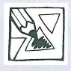
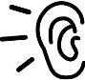
AUTUMN

THIS IS ME. I AM ______________________.
I AM ______________________.
HIS IS ME
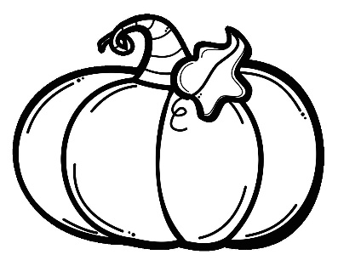
- LET'S DRAW AND COLOUR. HOW ARE YOU, PUMPKIN?
GRUMPY
I AM GRUMPY.
FUNNY
I AM FUNNY.
SLEEPY
I AM SLEEPY.
ANGRY
I AM ANGRY.
SAD
I AM SAD.
HAPPY
I AM HAPPY.

IF YOU'RE HAPPY
IF YOU'RE HAPPY, HAPPY, HAPPY, CLAP YOUR HANDS.
IF YOU'RE ANGRY, ANGRY, ANGRY, STOMP YOUR FEET.
IF YOU'RE SCARED, SCARED, SCARED, SAY, »OH, NO!«
IF YOU'RE SLEEPY, SLEEPY, SLEEPY, TAKE A NAP.

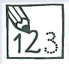
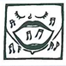
2. COMPLETE AND SING.

7

