AUTUMN

THIS IS ME. I AM ______________________.
I AM ______________________.
HIS IS ME
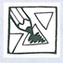

- AUTUMN IS HERE. LISTEN, DRAW AND COLOUR. POSLUŠAJ, NARIŠI IN POBARVAJ.
WHAT'S THE WEATHER LIKE?
IT IS COLD.
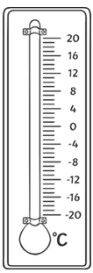
IT IS RAINY.
IT IS FOGGY.

WHAT DO YOU WEAR?

A RAINCOAT
AN UMBRELLA
RAIN BOOTS

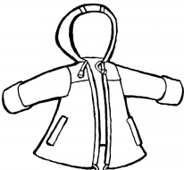
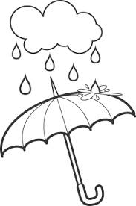
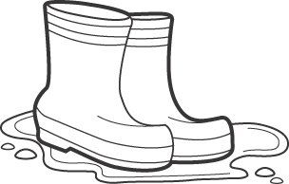

A SCARF
A JACKET
A HAT

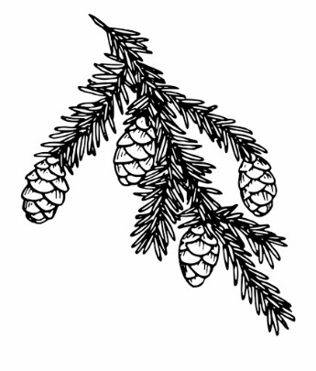
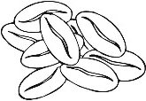
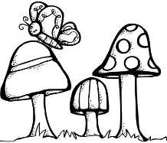
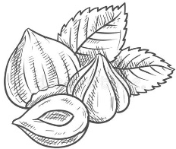
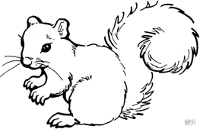
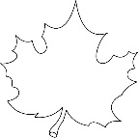
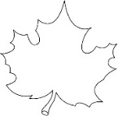
EVERGREEN LEAVES ARE ALWAYS GREEN.

LEAVES CHANGE COLOUR.
WHAT HAPPENS WITH NATURE AND ANIMALS?
WE PICK PUMPKINS.

ANIMALS LOOK FOR MUSHROOMS, NUTS AND SEEDS.

AUTUMN

THIS IS ME. I AM ______________________.
I AM ______________________.
HIS IS ME


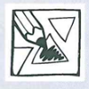

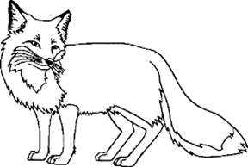
- COLOUR THE ANIMALS AS THE SONG SINGS. POBARVAJ ŽIVALI, KOT POJE PESMICA. SING. ZAPOJ.
GREY SQUIRREL
GREY SQUIRREL, GREY SQUIRREL, SHAKE YOUR FUNNY TAIL.
GREY SQUIRREL, GREY SQUIRREL, SHAKE YOUR FUNNY TAIL.
WRINKLE UP YOUR LITTLE NOSE, PUT A NUT BETWEEN YOUR TOES.
GREY SQUIRREL, GREY SQUIRREL, SHAKE YOUR FUNNY TAIL.
*WHITE MOUSE, YELLOW RABBIT, ORANGE FOX, BROWN BEAR, GREEN BIRD, BLUE OWL, BROWN DEER, BLACK WOLF, HEDGEHOG.

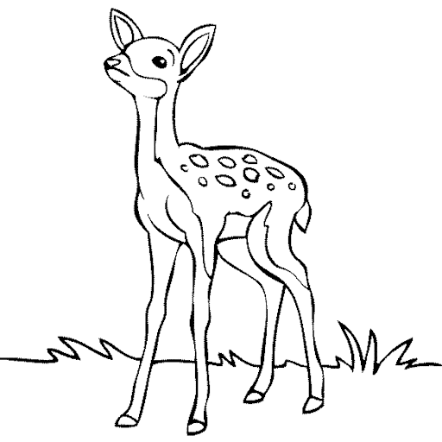
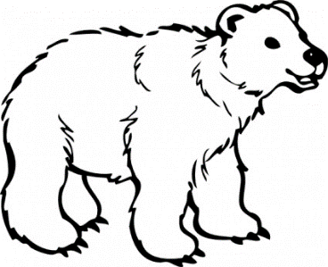
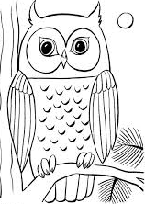

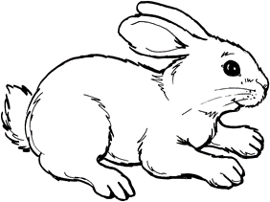

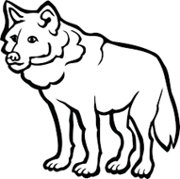
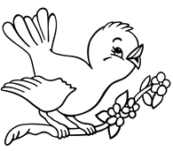

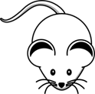
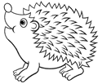

- LISTEN AND COLOUR CIRCLES. POSLUŠAJ IN POBARVAJ KROGE. WHAT ANIMAL IS THAT COLOUR? SAY AND COLOUR. KATERA ŽIVAL JE DANE BARVE? POVEJ IN POBARVAJ.
