AUTUMN

THIS IS ME. I AM ______________________.
I AM ______________________.
HIS IS ME


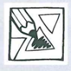

- COLOUR THE ANIMALS AS THE SONG SINGS. POBARVAJ ŽIVALI, KOT POJE PESMICA. SING. ZAPOJ.
GREY SQUIRREL
GREY SQUIRREL, GREY SQUIRREL, SHAKE YOUR FUNNY TAIL.
GREY SQUIRREL, GREY SQUIRREL, SHAKE YOUR FUNNY TAIL.
WRINKLE UP YOUR LITTLE NOSE, PUT A NUT BETWEEN YOUR TOES.
GREY SQUIRREL, GREY SQUIRREL, SHAKE YOUR FUNNY TAIL.
*WHITE MOUSE, YELLOW RABBIT, ORANGE FOX, BROWN BEAR, GREEN BIRD, BLACK WOLF, HEDGEHOG.

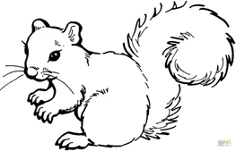
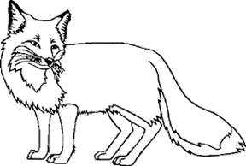

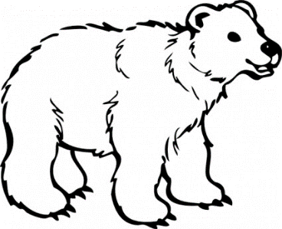
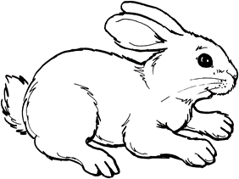
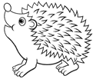

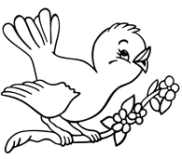
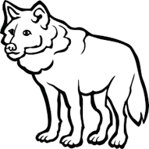
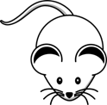

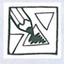

- LISTEN AND COLOUR CIRCLES. POSLUŠAJ IN POBARVAJ KROGE. WHAT ANIMAL IS THAT COLOUR? SAY AND COLOUR. KATERA ŽIVAL JE DANE BARVE? POVEJ IN POBARVAJ.
