PRISLOVI NAČINA (IN PRIDEVNIKI)
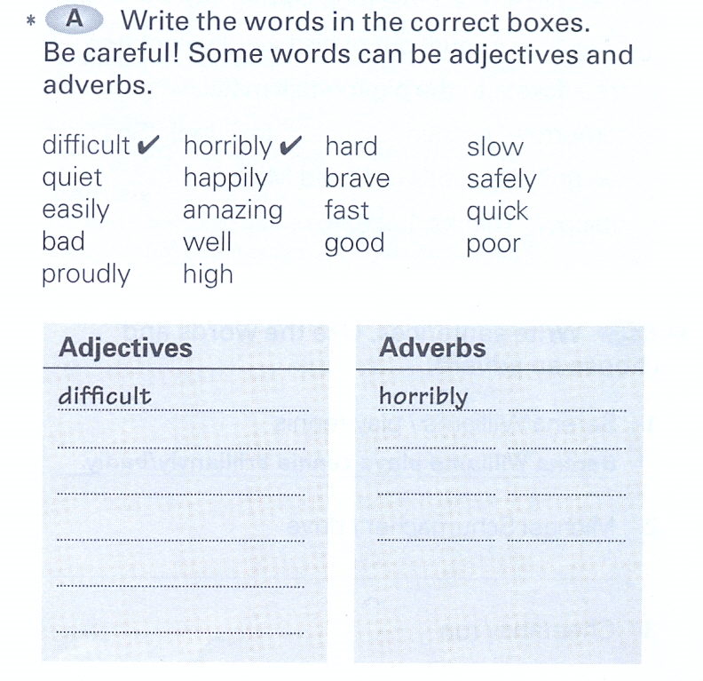
1)
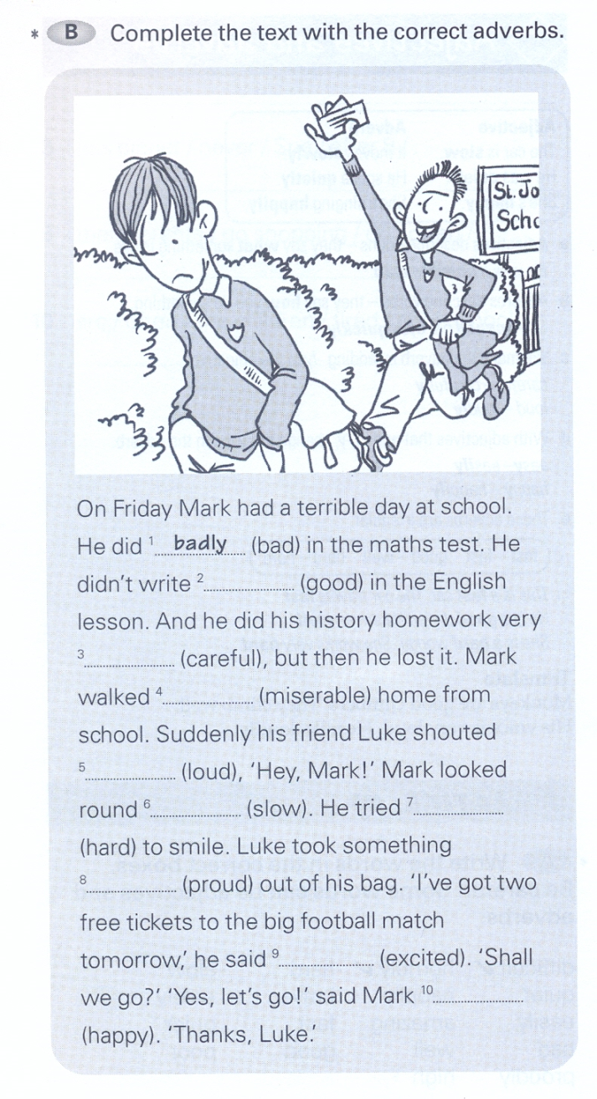
2)

3) Podčrtaj pravilno obliko –
pridevnik ali prislov (kakšen ali kako?).

My bedroom is tidy / tidily.
It’s raining heavy / heavily.
Cross the road careful / carefully.
My teacher was very angry / angrily.
Get ready for school quick / quickly.
The test was very easy / easily.
Your perfume smells nice / nicely.
Susan is smiling happy / happily.
He sings beautiful / beautifully.

4) Zapiši pravilno obliko – pridevnik ali prislov (Kakšen ali kako?).
- (careful) You must read the instructions _______________ before you use the machine.
- (noisy) Children are always very _______________
- (angry) Something had happened to him. He had an _______________ look.
- (beautiful) Don’t you think she paints _______________ ?
- (free) She will understand anything you tell her. You can talk to her _______________
- (clear) It’s important that you write all the details _______________
- (good) He plays tennis very _______________
- (slow) I have to buy a new car. This one is very _______________
- (warm) They gave us a very _______________ welcome.
- (comfortable) When I arrived he was sitting _______________ in an armchair.
- (hard) We worked _______________ all day.
- (fast) Don’t drive so _______________! It’s dangerous.
- (easy) It wasn’t _______________ to find their house in the middle of the night.
- (happy) When I gave him the present, he looked at me _______________.

