NAREDI NALOGE 1, 2, 3, 4, 5, 6, 8, 12



NAREDI NALOGE 6 IN 7

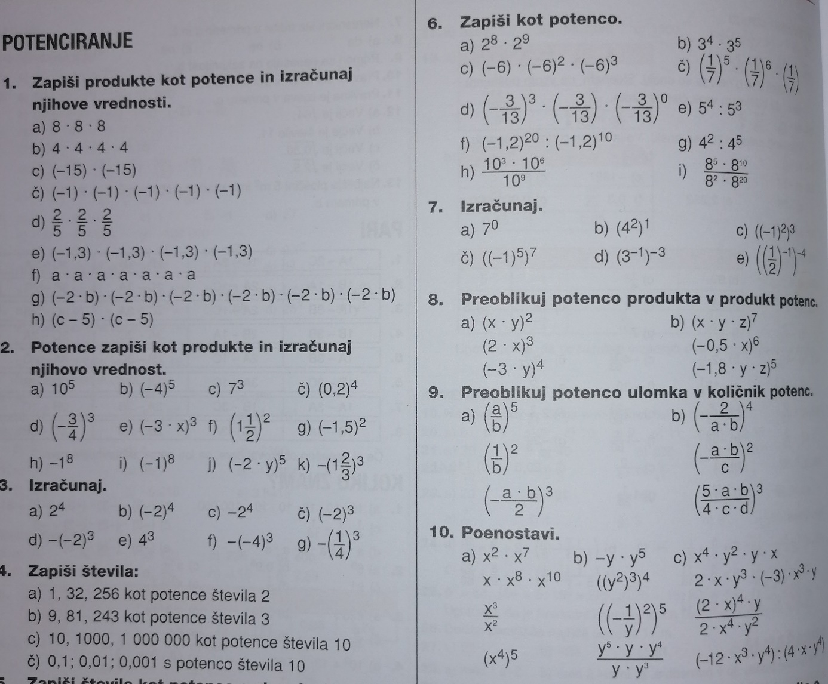

NAREDI NALOG0 19

