Pozdravljen, Patrik!
Danes se boš naučil, kako povedati, koliko je ura. V zvezek napiši naslov WHAT'S THE TIME? Prepiši in nariši ure.
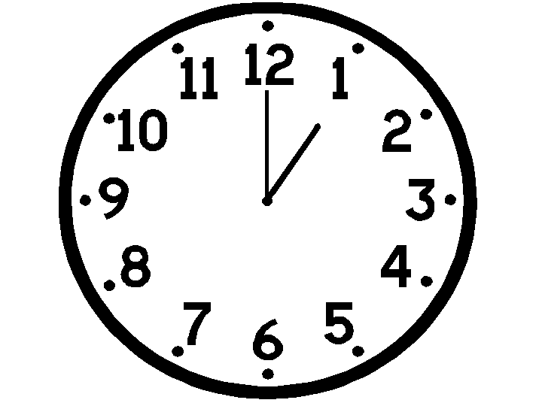
What's the time?
It's one o'clock.
(1.00)

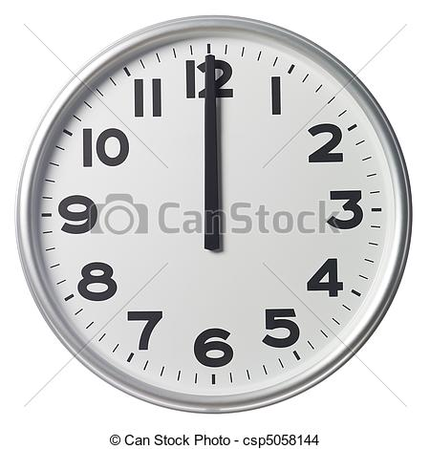
What's the time?
It's twelve o'clock.
(12.00)

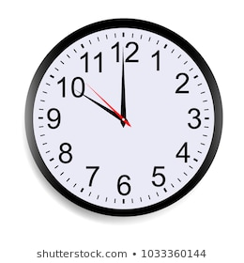

What's the time?
It's ten o'clock.
(10.00)

What's the time?
It's half past six.
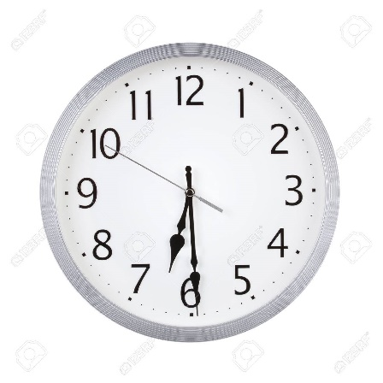
(6.30)

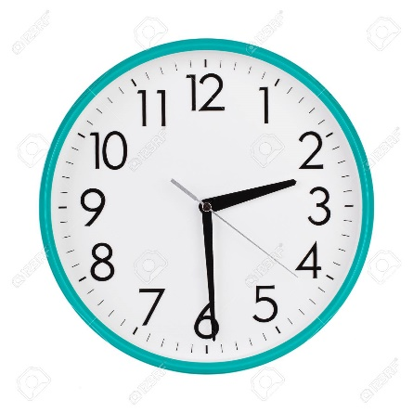
What's the time?
It's half past two.
(2. 30)

Sedaj pa odpri učbenik na strani 40 in 41 ter preberi, kaj počne Tim čez dan. Nato v zvezek prepiši čas in kaj Tim počne (ura in besedilo pod sliko).
V sredo pa se vidiva na videokonferenci.
Učiteljica Simona

