MY FAVOURITE TOY
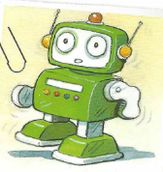
(Moj najljubša igrača)

My favourite toy is a robot. It's green and white. It's great!
It can walk and it can say ‘hello’!

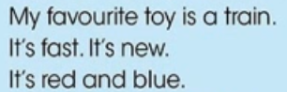
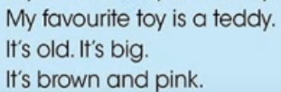
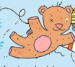

new – nov
old – star
big – velik
fast – hiter
It can walk. – Zna hoditi.
It can say 'hello'. – Zna reči 'zdravo'.

