REVISION
Opiši sobo. Uporabi predloge: in, on, under.
A doll is on the bed.
A book is on the desk.
A robot is on the chair.
A car is under the chair.
A skateboard is under the bed.
A ball is under the bed.
A ruler is under the table.
A dinosaur is on the cupboard.
A boat is in the cupboard.
A pencil case is on the floor.
Colour pencils are on the floor.
A (school) bag is on the floor.
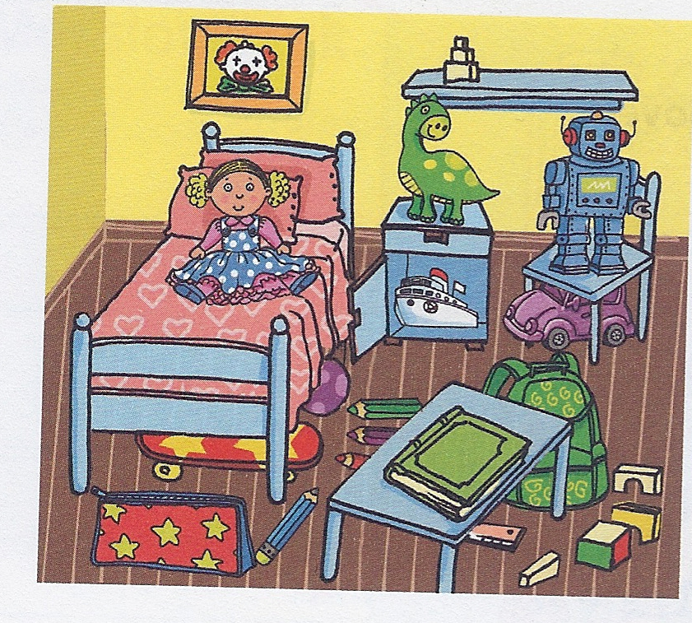

Poveži povedi.
Who's this? It's a book.
Have you got a plane? On the cupboard.
What's this? Blue.
Where is Otto? No, I haven't.
What's your favourite colour? It's number four.
What's your favourite number? My best friend Tom.

