EPI BRALNA ZNAČKA 2020/21
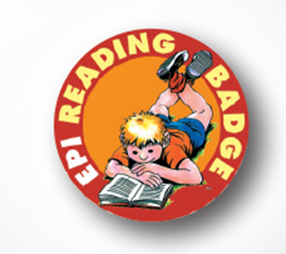

3. RAZRED
Rex and the big Dinosaur
Animal Colors
The Magic Porridge Pot

4. RAZRED
Topsy and Tim Go to the Zoo
Baby Animals
Marvel Avengers: Freaky Thor Day

5. RAZRED
Spider-Man: The Swashbuckling Spider
Wild Animals
Dinosaurs
The Wolf & the Little Kids

6. RAZRED
Space
Alice in Wonderland
The Magic Finger
Great Buildings
Sherlock Holmes Stories

7. RAZRED
Moby Dick + MP3 avdio CD
The Last of the Mohicans
Dr. Who: The Girl Who Died
Muhammad Ali
Dracula and his Family

8. RAZRED
Dr. Who: Face the raven
The Turn of the Screw
London
Dr. Who: Robot of Sherwood
The Battle of Newton Road

9. RAZRED
Flatline
Sweeney Todd + MP3 multirom
Strangers on a Train
The Cellist of Sarajevo
The Story of Popular Music

