https://www.pinterest.com/pin/782289397770623508/
https://www.pinterest.com/pin/591801207274810065/
https://www.pinterest.com/pin/591801207274905493/
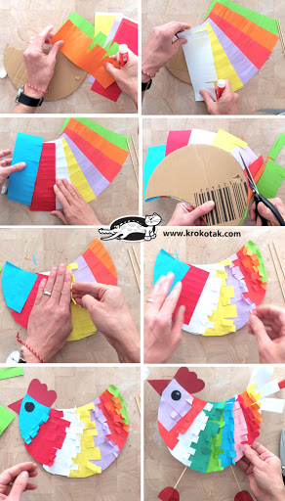
http://krokotak.com/2017/03/paper-plate-hens/
http://krokotak.com/2020/02/paper-tulips-2/
http://krokotak.com/2014/04/fluffy-chickens/
http://krokotak.com/2020/04/how-to-make-a-paper-helicopter/
http://krokotak.com/2017/04/baskets-sleeping-bunnies/
http://krokotak.com/2013/04/3-toilet-roll-egg-stands/

