Di che colore e'?
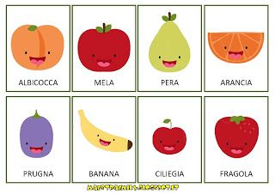
L'albicocca e' _____________________________
La mela e' ________________________________
La pera e' _______________________________
L'arancia e' ______________________________
La prugna e' ______________________________
La babana e' ______________________________
La ciliegia e' _____________________________
La fragola e' _____________________________

