1) Števila zapiši z besedo.

1 | 4 | 7 | 10
2 | 5 | 8 | 11
3 | 6 | 9 | 12
13 | 14 | 15 | 16
17 | 18 | 19 | 20

2) Prevedi izraze.

zelena peresnica | a
modra radirka | a
rdeče ravnilo | a
roza knjiga | a
vijoličast svinčnik | a
belo pero | a
rjav dinozaver | a
siv tovornjak | a
črn avto | a
oranžna punčka | an
rumen vlak | a
zelen robot | a

3) Poglej slike in odgovori na vprašanja.
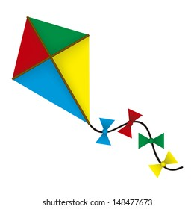
What's this?

It's a ____________________.


What's this?

It's a ____________________.

What's this?
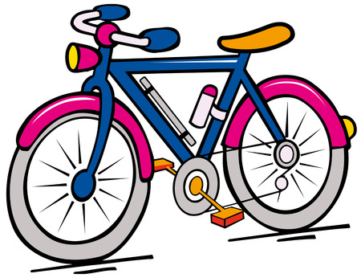

_________________________.

What's this?

__________________________.

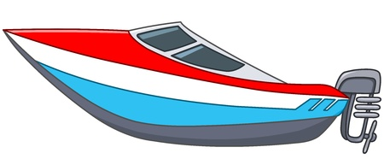
What's this?
___________________________________

4) Poimenuj hrano na sliki.

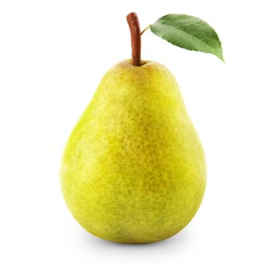
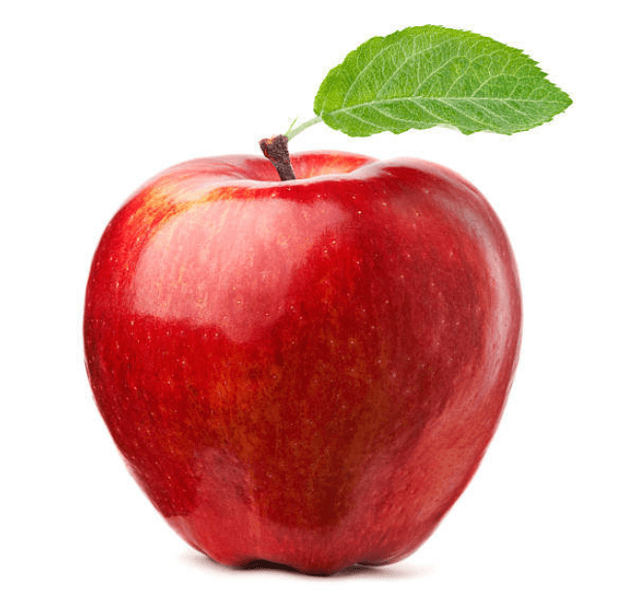

an ___________________ an ____________________ a ______________

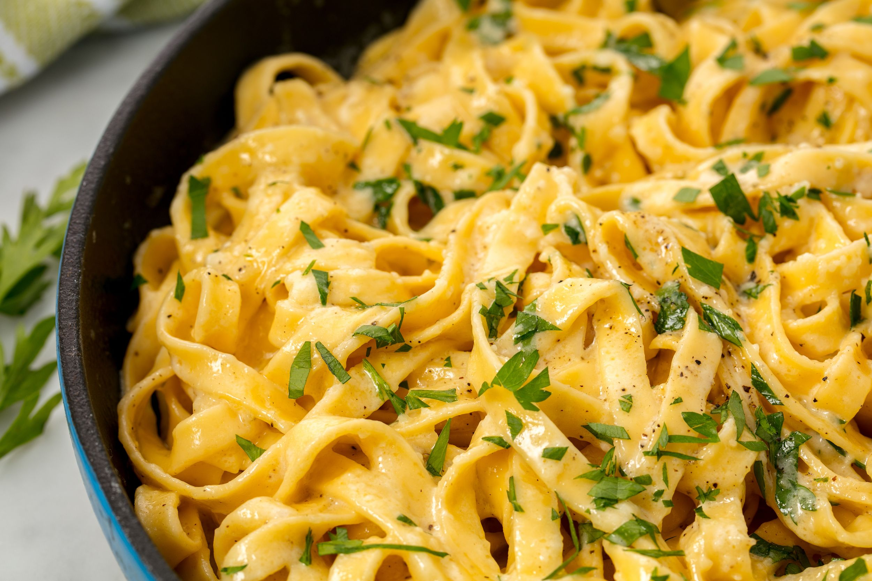
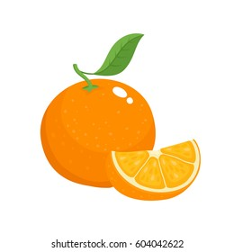
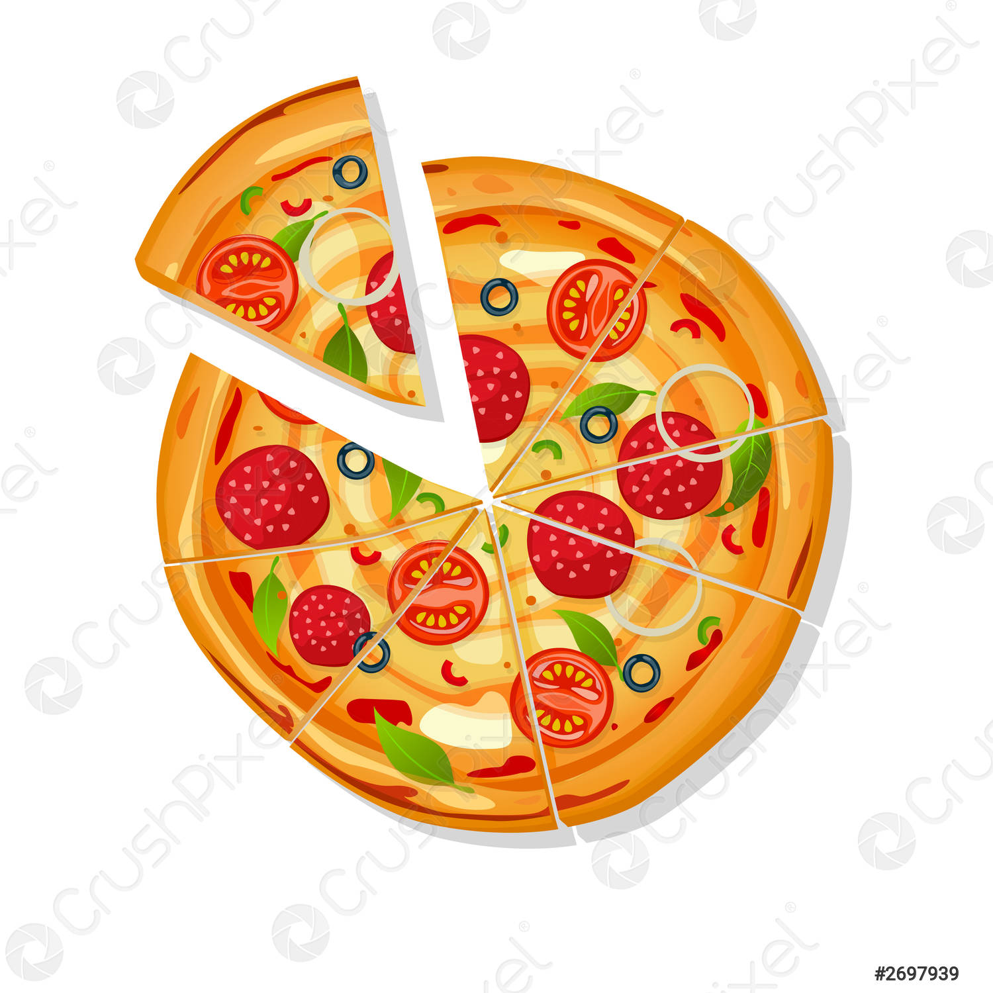

___________________ an _________________ __________________

__________________

1) Števila zapiši z besedo.

1 | 12 | 36 | 79
2 | 13 | 45 | 87
3 | 15 | 68 | 99
4 | 19 | 74 | 100
11 | 21

2) Prevedi izraze.

zelena peresnica | a
modra radirka | a
rdeče ravnilo | a
roza knjiga | a
vijoličast svinčnik | a
belo pero | a
rjav dinozaver | a
siv tovornjak | a
črn avto | a
oranžna punčka | an
rumen vlak | a
zelen robot | a

3) Poglej slike in odgovori na vprašanja.
What's this?

It's a ____________________.

What's this?

It's a ____________________.

What's this?

_________________________.

What's this?
__________________________.

What's this?
___________________________________

4) Poimenuj hrano na sliki.

an ___________________ an ____________________ a ______________

___________________ an _________________ __________________

__________________

