1) Napiši, katero hrano imaš rad in katere ne maraš.

2) Napiši, katere igrače imaš in katerih nimaš.

3) V okvirčke vpiši ustrezne besede.
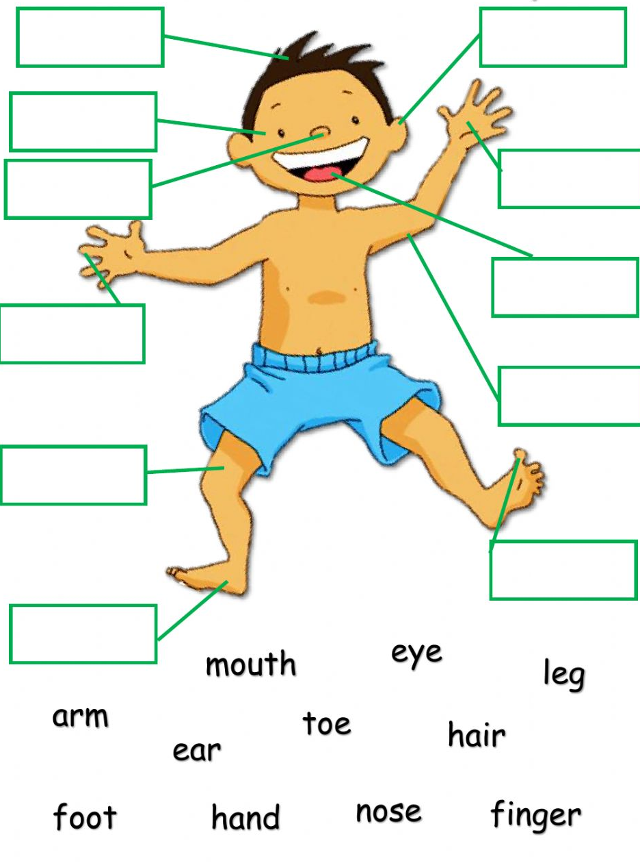

4) Poglej sliko in dopolni povedi s predlogi IN, ON, UNDER.

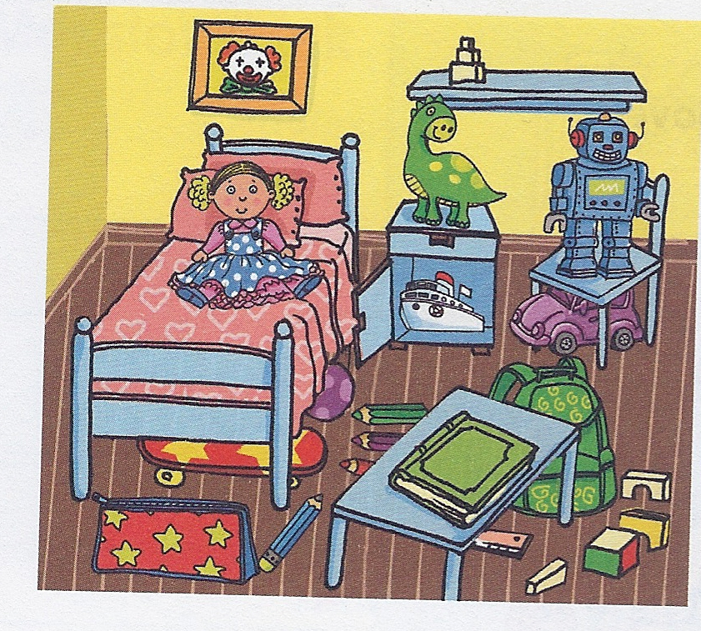
A doll is _______ the bed.
A ball is ___________ the bed.
A ruler is under the desk.
A dinosaur is __________ the cupboard.
A boat is __________ the cupboard.
A pencil case is _______ the floor.

A book is _______ the desk.
A robot is ________ the chair.
A car is _________ the chair.
A skateboard is ___________ the bed.

5) Prevedi besede.
ženska a ________________ mama _____________
moški a ________________ oče _____________
fant a _________________ brat ______________
deklica a _________________ sestra _______________
babica ___________________ dedek __________________
dojenček __________________

