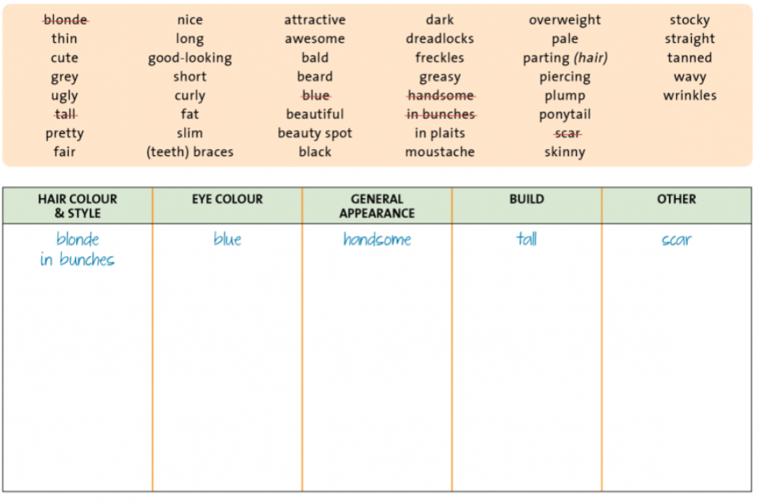
short-sighted

quiet | lively | stubborn | indecisive | patient | impatient
tih | živahen
calm | nervous | adventurous | unadventurous | selfish | unselfish
calm | energetic | enthusiastic | uninterested | amuzing | boring
clever, bright | stupid, silly | Hard-working | lazy | shy, coy | open
neat, tidy, well-organized | messy, untidy  disorganized | secure | insecure | honest | dishonest
reliable | unreliable | flexible | rigid | responsible | irresponsible
competetive | uncompetetive | lively, bubbly | dull | polite | impolite
sociable | unsociable | helpful | unhelpful | naive | careful  cautious
bossy | obedient | generous | mean | determined =  tolerant =  jealous =  bossy =
friendly | unfriendly | trustworthy | irresponsible
compassionate creative judgmental loyal curious
ambitious greedy sensitive modest quick-tempered pushy

