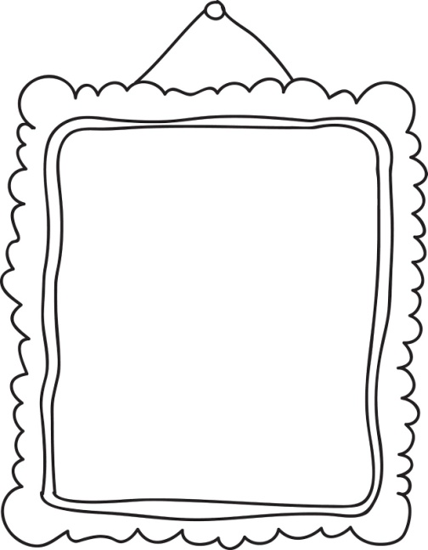
ABOUT ME MY PICTURE

My name is _____________________.
My surname is _____________________.
I am _____________ years old.
I live in ________________________.
I'm from ________________________.
I have got ________________ hair and _____________ eyes.
I go to ___________________________________________________. (šola)
I'm in class _________________. (razred)
My English teacher is miss ______________________.
I like _______________________, I don't like _____________________. (hrana)
My favourite colour is ______________________.
My favourite number is _______________________.
My best friend is ______________________.

What’s your name?
What’s your surname?
Where do you live?
Where are you from?
How old are you?

