Spain quiz

I. Discuss the dishes in the photo with your group leader and report (ingredients, taste…)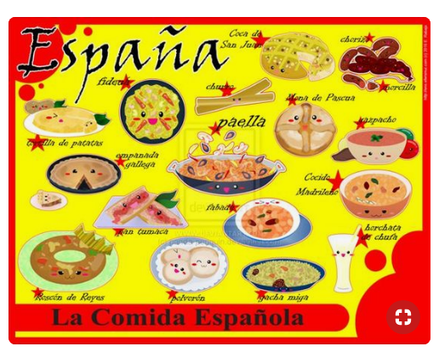
II. Fill in the gaps – ask your guests to assist you

1. Spain shares a _____________ with Portugal and France.
2. The _____________ of most people in Spain is Catholic.
3. The capital of Spain, _____________, is in the _____________ of the country.
4. The _____________ of Spain is about forty million.
5. There was a _____________ war in Spain from 1936 to 1939.
6. Barcelona and Seville are _____________ in Spain.
7. The _____________ of Mallorca, Tenerife and Ibiza are part of Spain.
8. Some people in the Basque region do not want to be part of Spain: they would like to be an _____________ country.
9. _____________ is important for the Spanish economy.
10. Spain’s national _____________ is paella, a mixture of rice and vegetables with seafood or meat.
11. Flamenco is a _____________ dance in Spain.
12. Between 20 and 25 percent of Europe’s _____________ are in Spain.
13. Andalucia is a _____________ in the south of Spain.
14. Pedro Almodovar is a very popular Spanish film _____________.
15. The area around Jerez in the south of Spain _____________ sherry, a well-known _____________ drink.
16. Spain is _____________ of the European Union.
17. Millions of British people go on holiday to Spain _____________ year.
18. One cultural difference between Spain and Britain is that Spanish people often like to have dinner late at night, _____________ if they are eating out at a restaurant.

III. Translate into English
