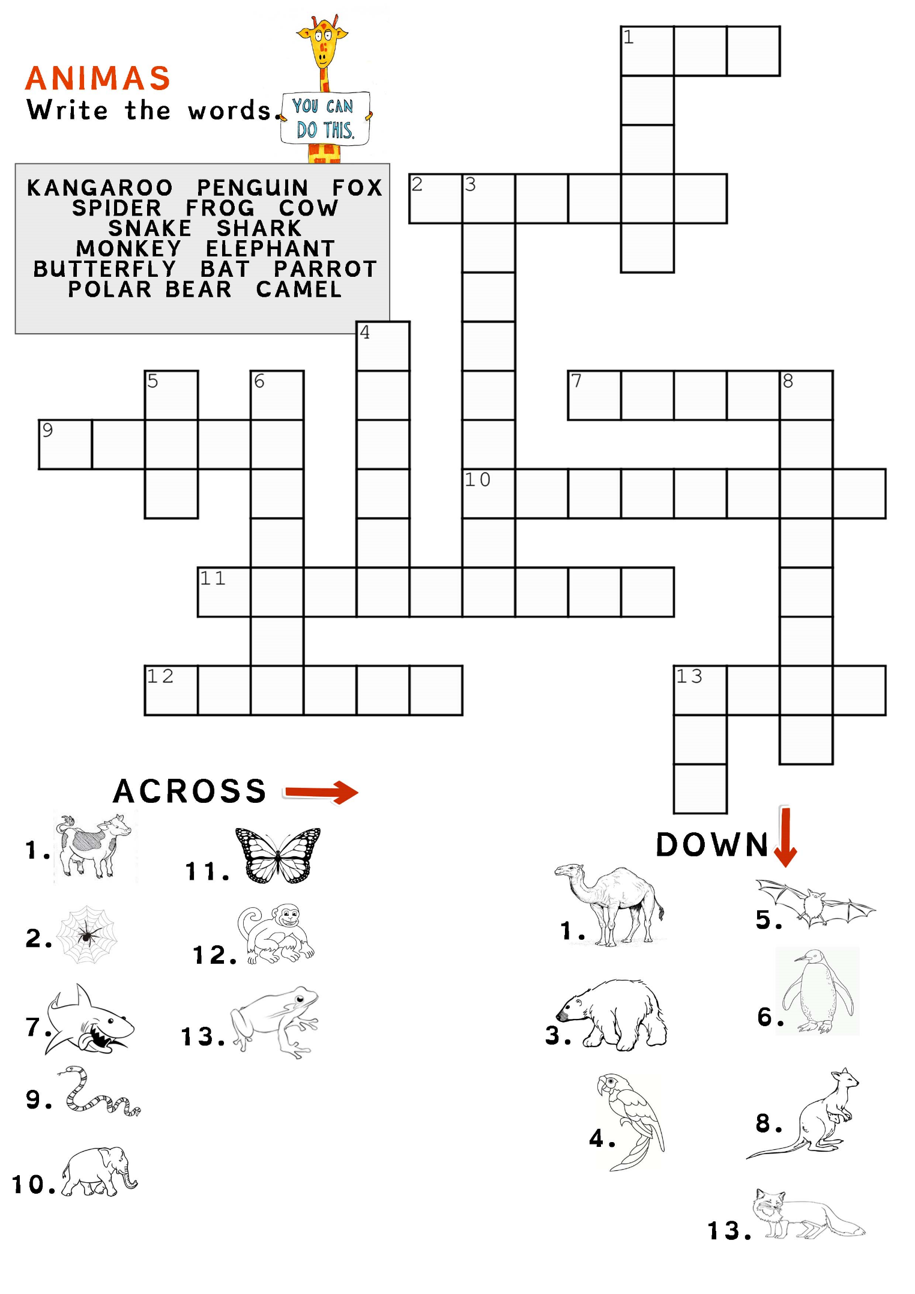
Colour the monkey pink. The camel is light blue. There is an orange frog.

The shark is yellow. The snake is dark green. Colour the elephant red.

