
Preverjanje znanja iz angleščine v 9. razredu U1

- Dopolni razpredelnico z ustrezno obliko in/ali prevodom nepravilnih glagolov.
INFINITIVE | PAST SIMPLE | PAST PARTICIPLE | SLOV. PREVOD
break
 | brought
 |  | sung
 |  |  | vreči
wear
 | took

- Dopolni tabelo z manjkajočimi +, - in /ali ? povedmi.
+ | - | ?
Kevin is reading a book.
 |  | Did Mark give her a kiss?
 | It isn’t going to rain soon.
We were having a test.
 |  | Will she talk to him?
 | He doesn't go out every day.
 | Sally hasn't met my brother.

- Glagole v oklepajih postavi v ustrezno obliko.
- Present Simple ali Present Continuous
- What _____________ you ________________ (do)? - I _________________ (look for) my slippers. I can’t find them anywhere. _______________ you _________________ (know) where they ______________ (be)?
- Past Simple ali Past Continuous
- She ___________________ (walk) down the street when she ____________________ (slip) on a banana skin. Fortunately, she _____________________ (not fall).
- What __________________ you __________________ (do) when the earthquake _______________ (begin)?
- Will Future ali Going to Future
- We ____________________ (spend) next weekend at our country cottage. We have already invited our friends to join us for the party.
- Some scientists predict that in not so distant future a huge asteroid ____________________ (hit) Earth and most life-forms ____________________ (not survive) the impact.
- Past Simple ali Present Perfect
- We ___________________ (book) a holiday online a month ago.
- ______________ your sister _______________ (pay) you back yet?
- I _______________________ (just, buy) a new computer.
- ______________ you ever ________________ (be) abroad? – Of course, I have.
- How long _____________ your brother _______________ (have) his motorbike?
- My dad _________________ (work) for Sava for 35 years. He doesn't work there anymore.

- Prvi pogojnik. Glagole v oklepajih postavi v ustrezno obliko in smiselno dokončaj zadnji dve povedi.
- If my dad isn’t busy, he ____________________ (take) me to practice.
- He won’t finish on time unless he ___________________ (hurry).
- If Tim __________________ (have) enough time, he _________________ (do) all the tasks.
- The greeting card ___________________ (arrive) on time if you _________________ (send) it today.
- If you eat all this chocolate, _________________________________________________.
- His parents will be angry if __________________________________________________.

- Pod sličice zapiši njihovo ustrezno poimenovanje v angleščini.
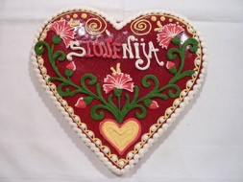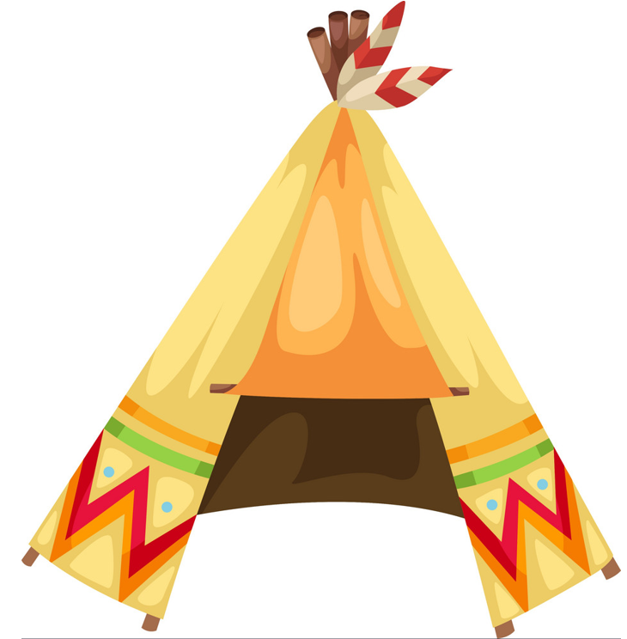
________________________ _______________________ __________________________ 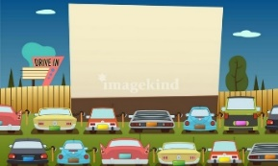 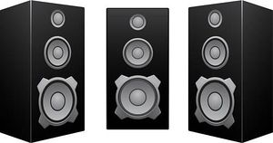 ________________________ ________________________ _________________________
- Dopolni besedilo z manjkajočimi besedami iz okvirja.
BATTLES CUSTOMS FOUND GOODS JOURNEY LAND MIDDLE AGES RESERVATIONS ROUTES SETTLERS SPICES THEMSELVES TRIBES

For thousands of years, people produced most of what they needed for ___________________. But little by little they realised that they could have more different __________________ by trading, so different trading links were established. For example, in the ____________________ people traded with India in precious stones, _____________________ and silk. That is why it was extremely important to the people of the then Europe to find another way to India because the ____________________ overland was very long and dangerous. For this reason, many explorers constantly searched for new and shorter sea ____________________. One of them was also Columbus. When he _____________________ America in 1492, he thought he was in India, so he called the people living there 'Indians'. Afterwards many European __________________ followed Columbus. Because they tried to take the ___________________ away from the Native Americans, there were many bloody ____________________ between the Indians and the white man. Unfortunately, the Indians didn't have such good weapons and many died, whereas the rest of them had to go live on ___________________. For thousands of years, the Native Americans have lived in small groups called ____________________ and each of them has its own language and ______________________.
P. S.: V preizkus bodo vključene tudi naloge slušnega in bralnega razumevanja ter pisni sestavek.

