GOING TO FUTURE – PRIHODNJIK Z 'GOING TO'

Uporabljamo ga za:
1) izražanje namenov, načrtov in odločitev za prihodnost
I'm going to have a party.

2) izražanje trdnih odločitev
I'm going to do my homework regularly.

3) izražanje predvidevanj
Look at the dark clouds. It's going to rain.

Časovni izrazi:
tomorrow, tomorrow night, in the afternoon, on Sunday morning,
next week, in May, in the summer, at the weekend

TRDILNA OBLIKA
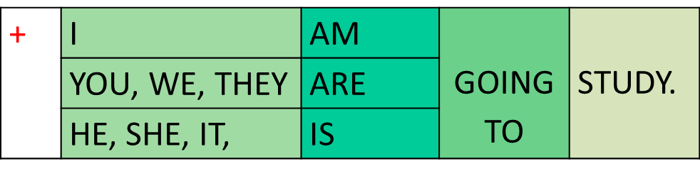

NIKALNA OBLIKA
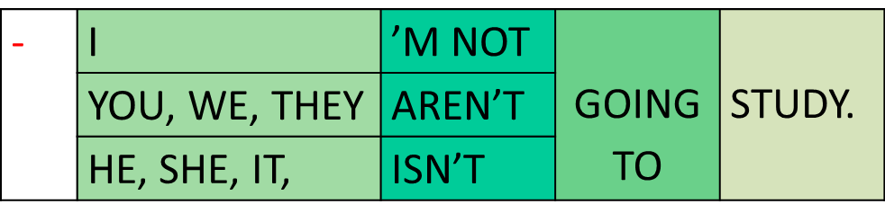

VPRAŠALNA OBLIKA
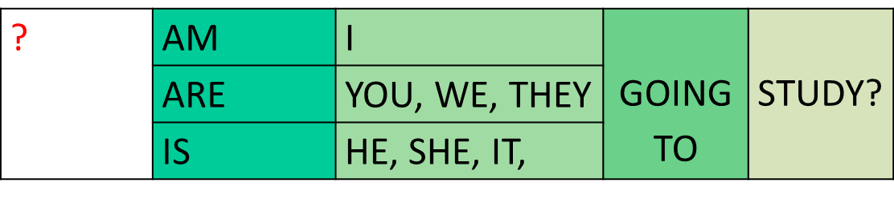
Yes, I am / No, I'm not.
Yes, he is. / No, he isn't.
Yes, we are. / No, we aren't.

